College Code: 9209
N.S.N College of Engineering and Technology

PROJECT DOCUMENTATION

SWIFT SHIP TRACKER
A Salesforce-Based Parcel Management System

Team Members

S.No | Name | Role
1 | Kowsika V S | Team Lead
2 | Harihara Sudhan M | Team Member
3 | Srinithi T | Team Member
4 | Parthiban J | Team Member

TABLE OF CONTENTS

User Story (Abstract) 4
- INTRODUCTION 4
  - Project Overview 4
  - Purpose 4
- IDEATION PHASE 5
  - Problem Statement (Customer Problem Statement Template) 5
  - Empathy Map Canvas 6
  - Brainstorming & Idea Prioritization 7
- REQUIREMENT ANALYSIS PHASE 8
  - Customer Journey Map 8
  - Solution Requirements 9
  - Data Flow Diagram 10
  - Technology Stack 11
- PROJECT DESIGN PHASE 12
  - Problem–Solution Fit 12
  - Proposed Solution 13
  - Solution Architecture 13
- PROJECT PLANNING & SCHEDULING 14
  - Project Planning 14
- PROJECT DEVELOPMENT PHASE 17
Phase 1: Requirement Analysis & Planning 17
Phase 2: Salesforce Development – Backend & Configurations 20
Milestone 1 – Salesforce Account 20
Milestone 2 – Objects Creation 22
Milestone 3 – Tabs 26
Milestone 4 – Fields & Relationships 28
Milestone 5 – Prompt Builder 35
Milestone 6 – Flows 38
Phase 3: UI/UX Development & Customization 43
Milestone 1 – Creating Permission Sets 43
Milestone 2 – Assigning Permissions to the Agent User 46
Milestone 3 – Org Setup for Agentforce 48
Milestone 4 – Building the Agent 49
Phase 4: Data Migration, Testing & Security 55
Verify Agent 55
Validate Assigned Topic 55
Check the Flow Association 57
Activate and Test the Agent 57
Validate Data in Salesforce 58
Phase 5: Deployment, Documentation & Maintenance 59
- FUNCTIONAL & PERFORMANCE TESTING 59
  - Test Cases 60
  - Results 60
  - Implementation Status 61
- ADVANTAGES & DISADVANTAGES 61
Advantages 61
Disadvantages / Limitations 62
- CONCLUSION 62
- FUTURE SCOPE 62
- APPENDIX 63
- REFERENCES 63

SWIFT SHIP TRACKER

User Story (Abstract)
The Swift Ship Tracker is designed to provide a centralized Salesforce-based parcel management solution that enables customers to book parcels, track delivery status, and manage shipments through an intuitive interface and conversational AI support. The system manages Parcel, Delivery, Sender, and Receiver information using Salesforce custom objects and relationships. Flows automate parcel operations and notifications, while Agentforce AI and Prompt Builder enable customers to retrieve parcel information and interact with the system conversationally. Delivery agents can update parcel status in real time, while Experience Cloud, security controls, reports, and dashboards provide secure customer access and operational visibility.

INTRODUCTION

Project Overview
The Swift Ship Tracker is a Salesforce CRM solution developed to simplify parcel booking, shipment tracking, and delivery management. It supports the complete parcel lifecycle from booking and dispatch through tracking and delivery confirmation. Customers can access shipment information, while delivery agents can update parcel details and delivery status.

Purpose
The purpose of Swift Ship Tracker is to:
    - Centralize parcel and delivery information.
    - Simplify parcel booking and tracking.
    - Provide real-time shipment visibility.
    - Automate delivery updates and customer notifications.
    - Enable conversational parcel tracking using Agentforce AI and Prompt Builder.
    - Improve agent efficiency through Salesforce Flows and dashboards.
    - Provide secure, role-based access to customers, agents, support staff, and administrators.

IDEATION PHASE

Problem Statement (Customer Problem Statement Template)

PS | I am (Customer) | I’m trying to | But | Because | Which makes me feel
PS-1 | Customer / Sender | book a parcel easily | booking requires support assistance or multiple applications | parcel operations are not centralized | frustrated
PS-2 | Customer / Sender | track my parcel | I do not have a simple real-time tracking experience | shipment information is difficult to access | confused
PS-3 | Delivery Agent | update parcel status | status updates require manual handling | there is a need for centralized operational tracking | concerned
PS-4 | Customer | receive delivery updates | notifications may not be available at every delivery stage | communication needs to be automated | uncertain
PS-5 | Admin | monitor parcel operations | parcel flow and delivery performance are difficult to monitor | operational data needs centralized reporting | concerned

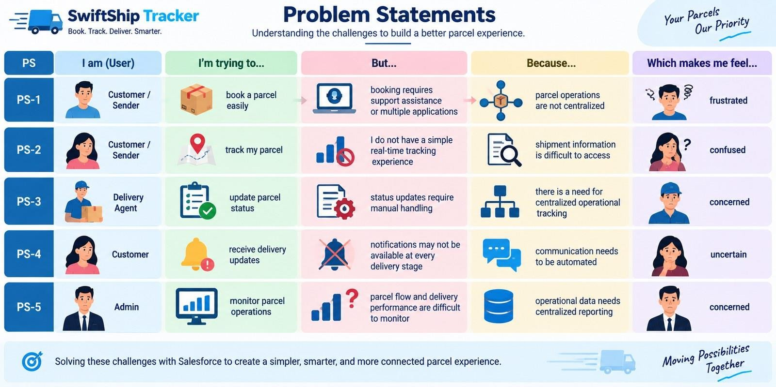
Figure 1: Problem Statements

Empathy Map Canvas
User Persona: Customer / Sender
    - Think & Feel: Wants a simple way to book and track parcels without repeatedly contacting support.
    - Hear: Receives delivery information and status updates from the parcel service.
    - See: Parcel details, tracking status, estimated delivery date, and delivery information.
    - Say & Do: Books parcels, checks tracking information, and asks for delivery updates.
    - Pain: Delays, confusion, lack of easy tracking, and dependence on support or multiple apps.
    - Gain: Real-time visibility, self-service tracking, convenient booking, and timely notifications.

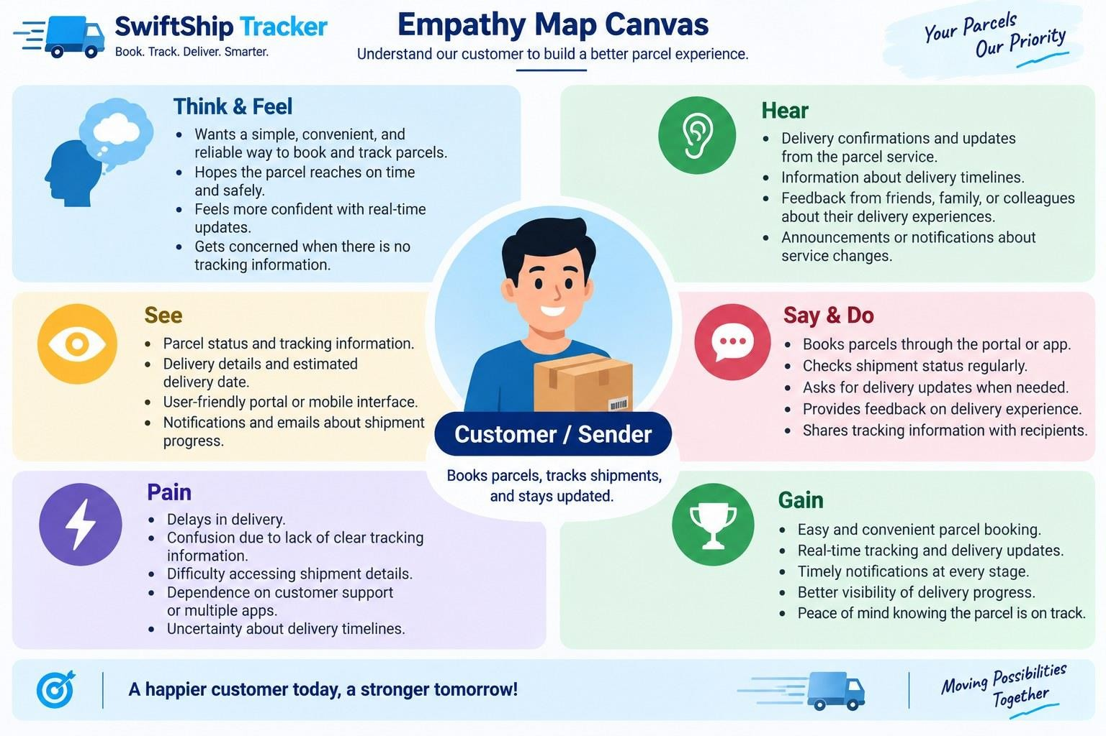
Figure 2: Empathy Map Canvas

Brainstorming & Idea Prioritization
Ideas Considered
    - Manual registers
    - Spreadsheet tracking
    - Standalone parcel portal
    - Salesforce CRM with Agentforce AI
Final Selection
Salesforce CRM selected due to:
    - Centralized parcel management
    - Automation through Flows
    - Real-time tracking visibility
    - Conversational AI assistance
    - Secure role-based access
    - Reports and dashboards

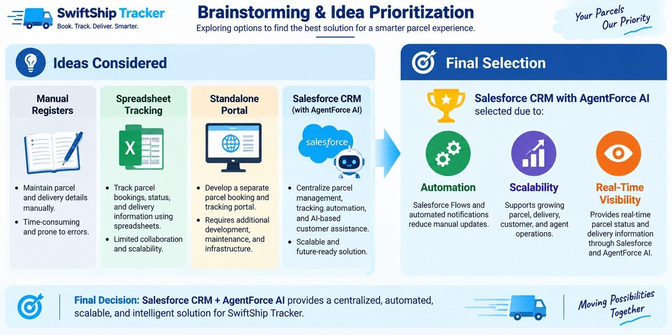
Figure 3: Brainstorming & Idea Prioritization

REQUIREMENT ANALYSIS PHASE

Customer Journey Map
Stages:
    - Parcel Booking
    - Parcel Record Creation
    - Dispatch & Shipment
    - In-Transit Tracking
    - Out for Delivery
    - Delivery Confirmation
    - Customer Notification
    - Feedback / Support

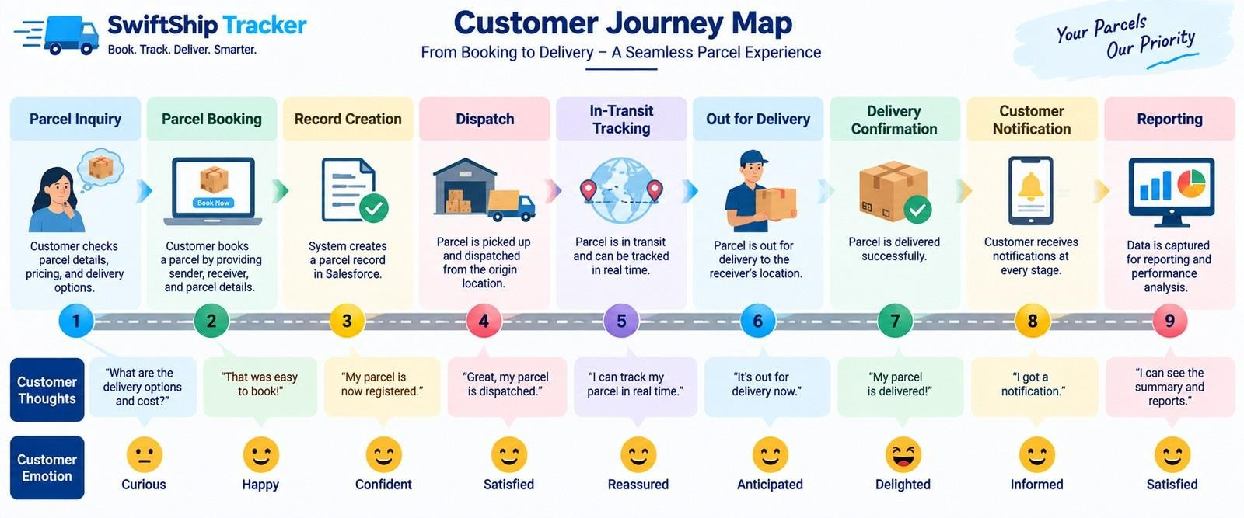
Figure 4: Customer Journey Map

Solution Requirements
Functional Requirements

FR No | Requirement
FR-1 | Parcel booking and record creation
FR-2 | Parcel status tracking
FR-3 | Weight management
FR-4 | Estimated delivery date management
FR-5 | Sender information management
FR-6 | Receiver information management
FR-7 | Delivery and current-location tracking
FR-8 | Agent parcel status updates
FR-9 | Automated customer notifications
FR-10 | AI-powered parcel tracking
FR-11 | Reports and dashboards
FR-12 | Customer access through Experience Cloud

Non-Functional Requirements

NFR | Description
Usability | Intuitive Salesforce and customer-facing interface
Security | Role-based and field-level access control
Reliability | Accurate parcel status and delivery information
Performance | Timely Flow and Agentforce responses
Availability | Salesforce cloud-based access
Scalability | Supports growing parcel and delivery operations
Data Integrity | Controlled access and relationship-based parcel data
Maintainability | Flows, prompts, topics, and configurations can be updated

Data Flow Diagram
Flow:
Customer / Sender
↓
Parcel Booking
↓
Parcel Record
↓
Sender + Receiver Information
↓
Delivery Record
↓
Parcel Status Update
↓
Current Location & Estimated Delivery
↓
Automated Notifications
↓
Customer Tracking / Agentforce AI
↓
Reports & Dashboards

AI Tracking Flow
Customer Query
↓
Agentforce AI
↓
Prompt Builder – Retrieve Parcel Details
↓
Parcel Record
↓
Status / Weight / Estimated Delivery
↓
Conversational Response

The Prompt Builder implementation retrieves Parcel ID, Status, Weight, and Estimated Delivery Date information for tracking responses.
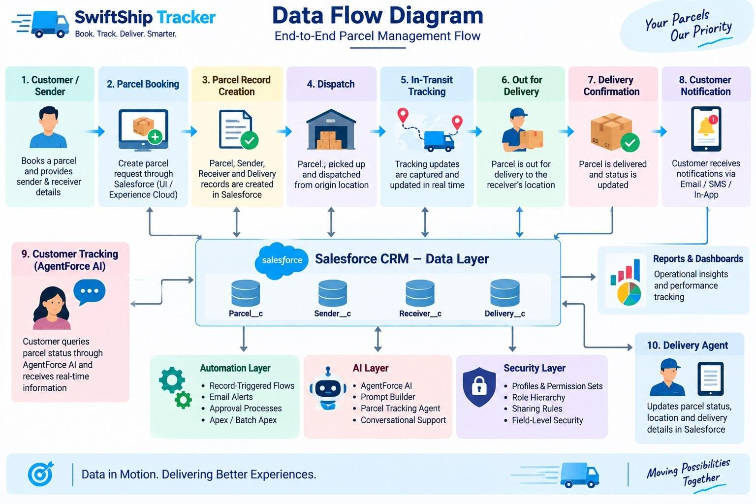
Figure 5: Data Flow Diagram

Technology Stack
The table below lists the technology stack of the solution together with its implementation status in the Developer Edition org (see Section 7.3).

Layer | Technology | Status
Platform | Salesforce Developer Edition | Implemented
UI | Lightning App (Parcel Tracker app with object tabs) | Implemented
 | Lightning Record Pages, Experience Cloud | Planned
Database | Salesforce Custom Objects (Parcel, Delivery, Sender, Receiver) | Implemented
 | Standard Objects (Account, Contact, Case, Task, EmailMessage, User) | Planned
Business Logic | Salesforce Flows | Implemented
 | Apex Classes | Planned

Layer | Technology | Status
Automation | Auto-Launched Flow (Parcel Details) | Implemented
 | Record-Triggered Flows, Scheduled Flows | Planned
AI | Agentforce AI, Prompt Builder | Implemented
Notifications | Email Alerts & Email Templates | Planned
Processing | Batch Apex | Planned
Security | Permission Sets (Swift Ship), Field Permissions | Implemented
 | Profiles, Role Hierarchy, Sharing Rules | Planned
Reporting | Reports & Dashboards | Planned

PROJECT DESIGN PHASE

Problem–Solution Fit

Problem | Solution | Benefit
Parcel booking is difficult | Salesforce Parcel management | Centralized booking
Tracking requires support | Agentforce AI + Prompt Builder | Self-service tracking
Manual status updates | Salesforce Flows | Automated processes
Delivery communication gaps | Email Alerts | Timely notifications
Scattered shipment information | Parcel, Delivery, Sender & Receiver objects | Structured data
Difficult operational monitoring | Reports & Dashboards | Better visibility
Different users need different access | Profiles, Roles & Permission Sets | Secure access

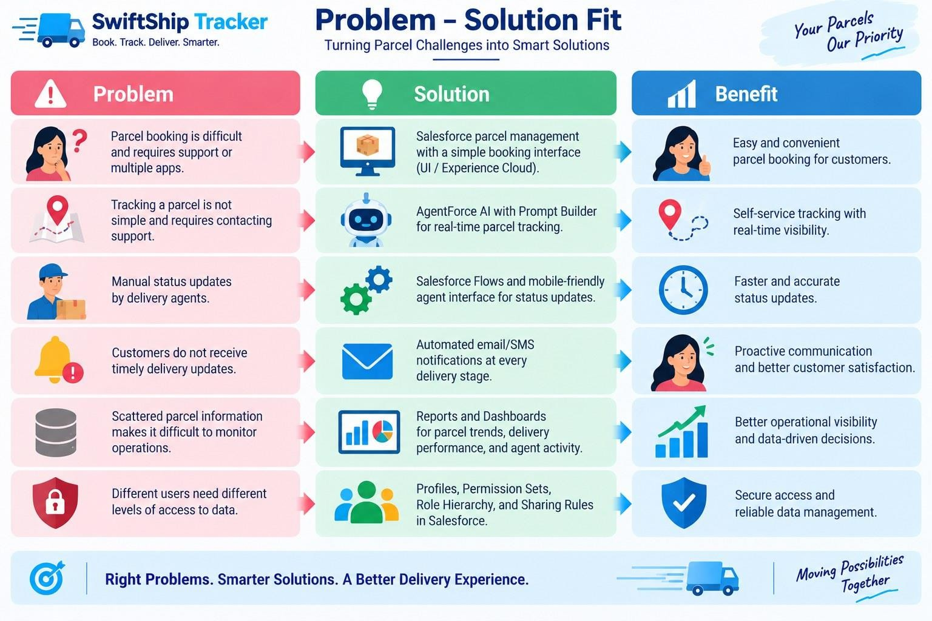
Figure 6: Problem–Solution Fit

Proposed Solution

Parameter | Description
Problem | Difficult and inefficient parcel booking and tracking
Solution | Salesforce-based Parcel Management System
Innovation | Agentforce AI + Prompt Builder for conversational self-service tracking and automated Salesforce Flows
Impact | Centralized booking, real-time tracking visibility, timely notifications, and efficient delivery management
Business Model | Parcel, customer, delivery-agent, support, and administrator operations
Scalability | Supports growing parcel operations, Experience Cloud, and integration with external logistics systems

Solution Architecture
Users: Customer | Delivery Agent | Support Staff | Admin

↓
Salesforce Lightning / Experience Cloud
↓
Swift Ship Tracker Salesforce Platform
    - Data Layer: Parcel, Delivery, Sender, Receiver
    - Automation Layer: Flows, Approval Processes, Apex Classes, Batch Apex, Email Alerts
    - AI Layer: Agentforce AI, Prompt Builder, Parcel Tracking Agent
    - Security Layer: Profiles, Roles, Permission Sets, Sharing Rules, Field-Level Security
↓
Reports & Dashboards
↓
Parcel Tracking & Operational Insights
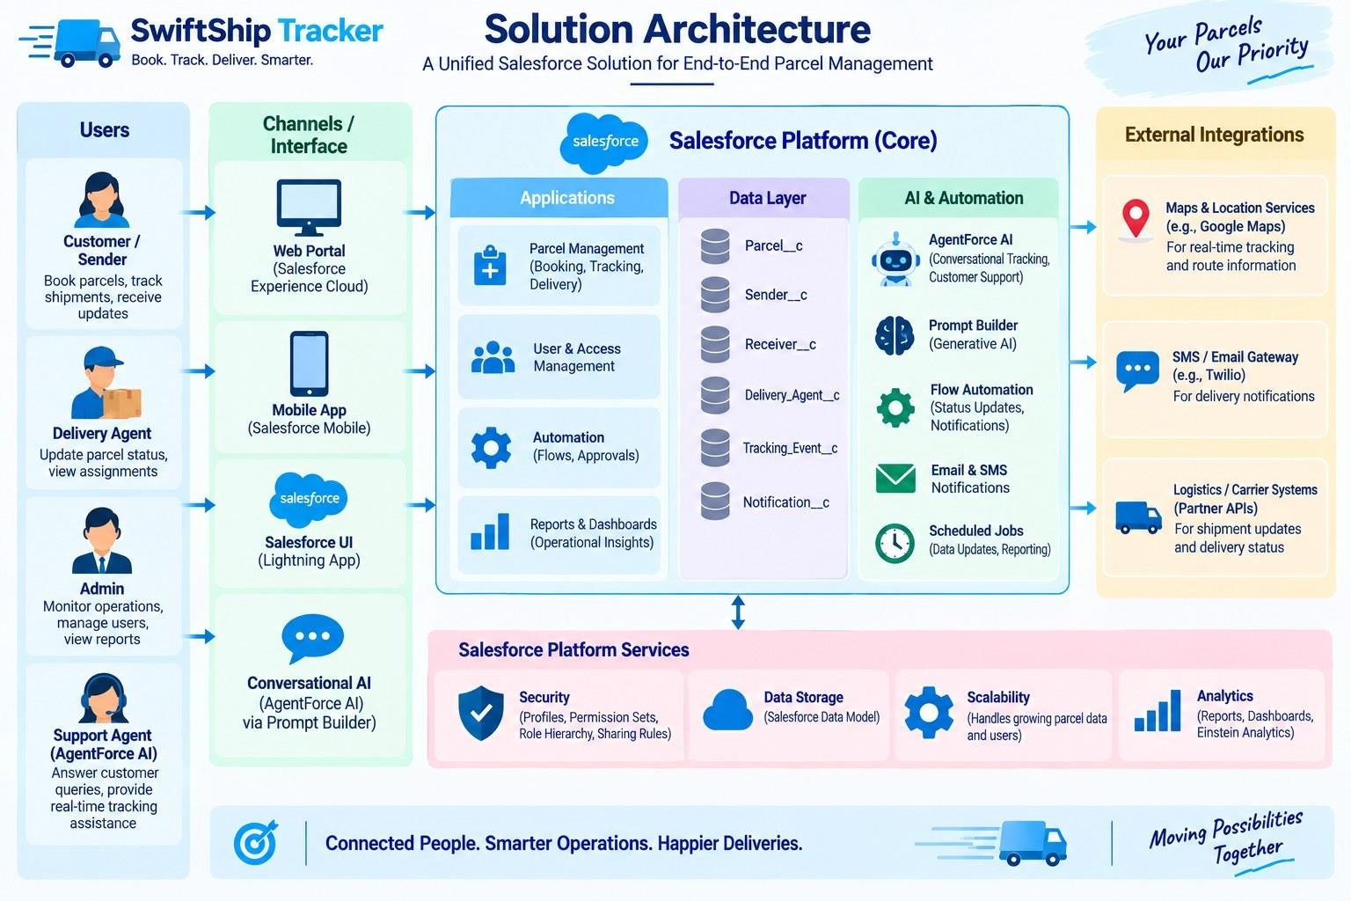
Figure 7: Solution Architecture

PROJECT PLANNING & SCHEDULING

Project Planning
    - Agile methodology
    - Epics → Stories → Story Points
    - Sprint-based execution
    - Velocity calculation used for estimation

Product Backlog, Sprint Schedule, and Estimation

Sprint | Functional Requirement (Epic) | User Story Number | User Story / Task | Story Points | Priority | Team Member
Sprint-1 | Developer Setup | USN-1 | As a system administrator, I want to create and configure the Salesforce environment so that I can build the Swift Ship Tracker parcel management system. | 3 | High | Chandru R
Sprint-2 | Data Modeling | USN-2 | As an admin, I want to create Parcel, Delivery, Sender, and Receiver objects with proper relationships so that parcel and delivery data is stored and managed systematically. | 5 | High | Buvanesh K
Sprint-2 | Data Modeling | USN-3 | As a staff member, I want dedicated tabs and a Lightning App for Swift Ship modules so that I can easily navigate and manage parcel and delivery operations. | 5 | High | Ashwinkumar D
Sprint-3 | Automation | USN-4 | As a system, I want to validate parcel details, mandatory fields, and booking inputs so that invalid or incomplete parcel records are prevented. | 3 | High | Dhanush M

Sprint | Functional Requirement (Epic) | User Story Number | User Story / Task | Story Points | Priority | Team Member
Sprint-3 | Automation | USN-5 | As a delivery coordinator, I want automated Flows to update parcel status and delivery information so that parcel processing requires minimal manual effort. | 3 | High | Dhanush M
Sprint-4 | Apex | USN-6 | As a system, I want Apex triggers and classes to automatically perform critical parcel and delivery actions so that important processes are handled accurately. | 5 | High | Chandru R
Sprint-4 | Apex | USN-7 | As an operations manager, I want Batch Apex jobs to process and update parcel or delivery records automatically so that operational data remains accurate and up to date. | 5 | High | Buvanesh K
Sprint-5 | Reports | USN-8 | As a manager, I want reports showing parcel status, delivery performance, and operational metrics so that I can monitor Swift Ship operations and make informed decisions. | 4 | High | Ashwinkumar D
Sprint-6 | Dashboards & AI | USN-9 | As a manager, I want dashboards showing parcel status, delivery performance, and key metrics, while Agentforce provides AI-powered tracking assistance, so that I can monitor operations efficiently. | 4 | Medium | Dhanush M

Project Tracker & Velocity

Sprint | Total Story Points | Duration | Story Points (from Product Backlog)
Sprint-1 | 3 | 6 Days | USN-1 (3)

Sprint | Total Story Points | Duration | Story Points (from Product Backlog)
Sprint-2 | 10 | 6 Days | USN-2 (5) + USN-3 (5)
Sprint-3 | 6 | 6 Days | USN-4 (3) + USN-5 (3)
Sprint-4 | 10 | 6 Days | USN-6 (5) + USN-7 (5)
Sprint-5 | 4 | 6 Days | USN-8 (4)
Sprint-6 | 4 | 6 Days | USN-9 (4)
Total | 37 | 36 Days | Average velocity ≈ 6.2 story points per sprint

PROJECT DEVELOPMENT PHASE

Phase 1: Requirement Analysis & Planning

Objective:
“Customers often face delays and confusion while booking, tracking, and managing parcel deliveries because they need to call support or use multiple apps. A conversational AI agent can simplify this by allowing customers to book parcels, get live tracking, and manage deliveries in one place.”

Key Requirements:
- Requirement gathering from end users and delivery agents.
- Defining system scope and user personas (Customer, Agent, Admin).
- Designing the data model with relationships between Parcel, Sender, Receiver, and Delivery.
- Identifying use cases such as parcel booking, tracking, and delivery update automation.
- Selecting tools: Salesforce Flows, Prompt Builder, and Agentforce AI.

Defining Project Scope & Objectives Project Scope:
- Build a scalable CRM solution for parcel delivery businesses to manage customer
bookings, shipments, and delivery operations efficiently.
- Support the end-to-end parcel lifecycle — from parcel booking → dispatch → tracking → delivery confirmation.
- Include comprehensive data model design, automation (Flows, Apex, Email Alerts), AI-powered Prompt Builder, and reporting dashboards for effective management.
- Provide role-based access for admins, delivery agents, and customers through Salesforce profiles, permission sets, and Experience Cloud.
- Ensure real-time parcel visibility for customers and simplified operational tracking for agents through AI-integrated conversational support.

Objectives Summary:

  - Streamline parcel operations by automating booking, tracking, and delivery notifications to reduce manual updates.
  - Improve customer satisfaction with transparent, real-time shipment status and self-service tracking options.
  - Enhance agent efficiency through centralized dashboards and guided Flows for quick status updates.
  - Enable business insights with reports and dashboards showing parcel trends, delivery performance, and agent activity.
  - Ensure security and reliability by implementing Salesforce role hierarchies, sharing rules, and audit-based data access.

Gathering & Analysing User Needs Users Involved:
  - Customers / Senders – End users who book parcels, track deliveries, and receive real-
time updates through the portal or AI agent.
  - Delivery Agents – Manage assigned parcels, update delivery status, and ensure timely handover to customers.
  - Customer Support Team – Handle delivery-related issues, respond to customer queries, and ensure smooth communication.
  - Admin Team – Configure the Salesforce environment, manage user roles, security settings, and monitor operational performance.
  - System Integrator / Developer – Responsible for implementing automation, AI agent setup, and backend integrations.

Key Functional Needs:
  - Seamless parcel booking and tracking interface for customers through Salesforce Experience Site or agent assistance.
  - Ability for agents to update parcel status (Booked → In Transit → Out for Delivery → Delivered) in real time.
  - Automated notifications and email alerts to customers on every delivery stage update.
  - Support for Sender and Receiver details management with address, contact, and email fields for communication.
  - AI agent integration (via Prompt Builder) for real-time parcel status queries and automated assistance.
  - Reports and dashboards to monitor parcel flow, delivery performance, and agent activity for admins.
  - Security controls with role-based access, profiles, and permission sets for different user levels.

Tools Used:
  - Salesforce Developer Org – For configuration, development, and testing.
  - Prompt Builder (Agentforce AI) – To create intelligent parcel tracking prompts and responses.

  - Salesforce Flow Builder – To automate booking, tracking, and delivery updates.
  - Google Sheets / Docs – For initial data planning, requirement documentation, and system mapping.

Identifying Key Salesforce Features & Tools Required Salesforce Features Planned:
  - Custom Objects: Parcel c, Delivery c, Sender c, Receiver c
  - Standard Objects: Account, Contact, Case, Task, EmailMessage, User
  - Automations: Record-Triggered Flows, Auto-Launched Flows, Approval Processes, Scheduled Flows
  - Apex: Apex Classes for automated parcel operations (e.g., Lead-to-Parcel mapping, delivery notifications), Batch Apex for periodic updates or notifications
  - UI: Lightning App Page (Swift Ship Tracker App), Dynamic Forms for Parcel Details, Lightning Record Pages, and Experience Cloud for Customer Access
  - Agentforce AI & Prompt Builder: Integrated AI agent trained to fetch parcel data based on Parcel ID and respond to tracking or delivery status queries
  - Email Services: Custom Email Alerts and Templates for booking confirmations, delivery updates, and completion acknowledgments
  - Security: Profiles, Permission Sets, Role Hierarchies, Field-Level Security, and Sharing Rules to ensure controlled access for Admin, Agent, and Customer roles

Designing Data Model and Security Model Data Model Includes:
  - Parcel c (Custom Object) – Stores core parcel details such as Parcel ID, Status,
Weight, and Estimated Delivery Date. Linked to Sender c and Receiver c objects to fetch sender and receiver details, and connected with the Delivery c object to track real-time parcel location and status.
  - Delivery c (Custom Object) – Stores delivery-specific information such as current location, estimated delivery date, and linked parcel. Connected with Sender c and Parcel c for relationship-based tracking, and used by agents to update and monitor delivery status during the parcel lifecycle.
  - Sender c (Custom Object) – Captures sender-related information such as address, contact number, and email. Linked to multiple parcels to track sender history and associated deliveries, and used for sending booking confirmations and delivery updates via automated emails.
  - Receiver c (Custom Object) – Stores receiver details such as address, contact, and email for communication and delivery confirmation. Linked to Sender c and Parcel c to associate both ends of the shipment process, and used by agents for delivery reference and automated email notifications upon completion.

Security Model Design:
  - Role Hierarchy: Administrator → Delivery Manager → Agent → Customer

  - Profiles: Admin Profile – full access to all objects and records. Delivery Agent Profile – Read/Edit access to Parcel, Delivery, Sender, and Receiver objects. Customer Profile – read-only access to their own parcel details via Experience Cloud. Support Staff Profile – access to Cases and Parcel details for issue resolution.
  - Permission Sets: Used to grant additional privileges (e.g., “Update Delivery Status”, “Access Agent Console”). The Swift Ship permission set implemented in this project is described in Phase 3.
  - Record-Level Security: Sharing Rules applied for Parcel c and Delivery c to allow controlled access for agents and managers. Customers can only view records linked to their own Sender or Receiver details.
  - Field-Level Security: Sensitive fields like Sender Email, Receiver Contact, and Location Coordinates restricted to Admin and Agent profiles only.

Phase 2: Salesforce Development – Backend & Configurations
This phase focused on developing the core logic of Swift Ship Tracker. Custom objects were created for Parcel, Sender, Receiver, and Delivery with relationships. A Prompt Builder template and an auto-launched Flow were built so that the Agentforce agent can retrieve parcel details.

Milestone 1 – Salesforce Account
Salesforce is a customer success platform that helps organizations sell, service, market, analyse, and connect with their customers. Swift Ship Tracker is built on a free Salesforce Developer Edition org, which provides the objects, Flow Builder, Prompt Builder and Agentforce features used in this project.

Creating Developer Account
Creating a developer org in Salesforce:
- Go to https://developer.salesforce.com/signup
- On the sign-up form, enter the following details:

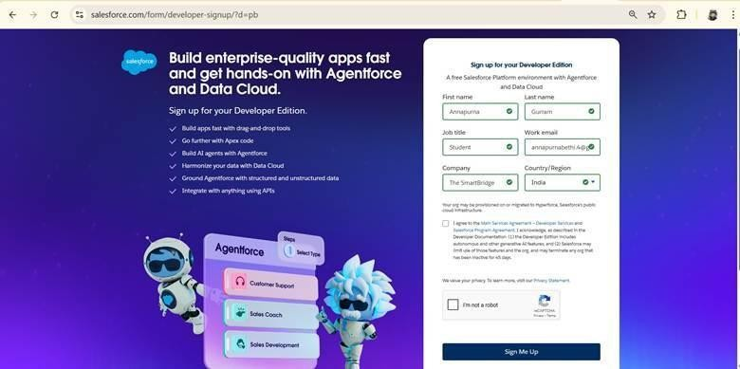
Figure 8: Salesforce Developer Edition sign-up form
- First name & Last name
- Email
- Job Title: Developer
- Company: N.S.N College of Engineering and Technology
- Country: India
Click on Sign Me Up after filling these.
Go to the inbox of the email that you used while signing up. Click on Verify Account to activate your account. The email may take 10–30 minutes and sometimes up to 2 hours.
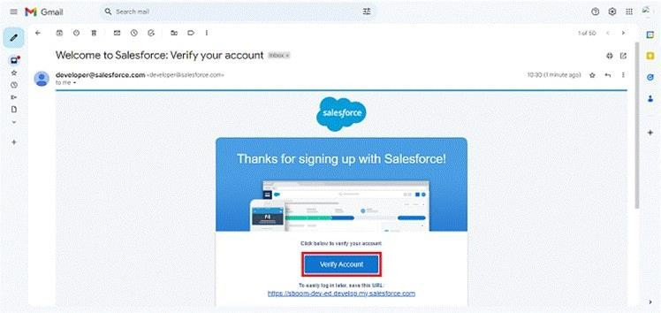
Figure 9: Account verification e-mail from Salesforce

- Click on Verify Account.
- Give a password and answer a security question and click on Change Password.
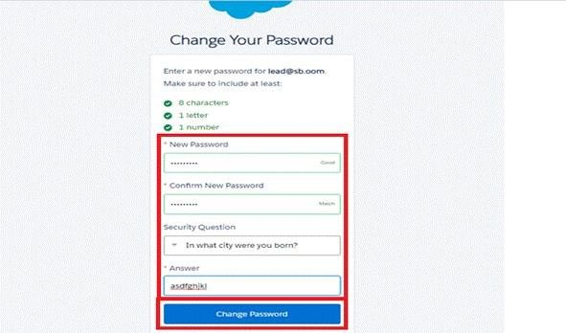
Figure 10: Change Your Password page
- Then you will be redirected to your Salesforce Setup page.
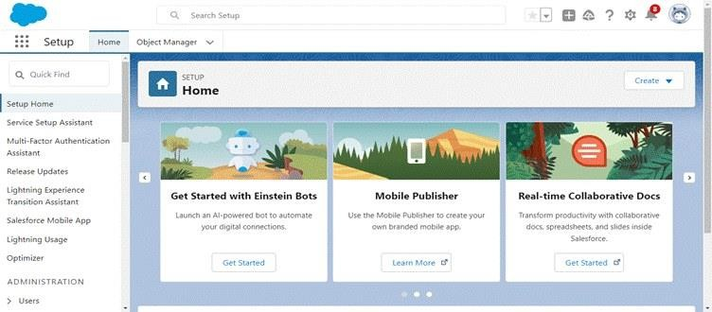
Figure 11: Salesforce Setup Home page

Milestone 2 – Objects Creation
To create the Parcel object:
- From the Setup page, click on Object Manager.
- Click on Create >> Custom Object.
- Enter the label name as Parcel.
- Enter Plural label name as Parcel’s (as shown in the org).
- Enter Record Name as Parcel Name.
- Select Data Type as Text: Parcel Name.

- Select Allow Reports.
- Select Allow Search.
- Allow Track Field History.
- Click on Save and New.
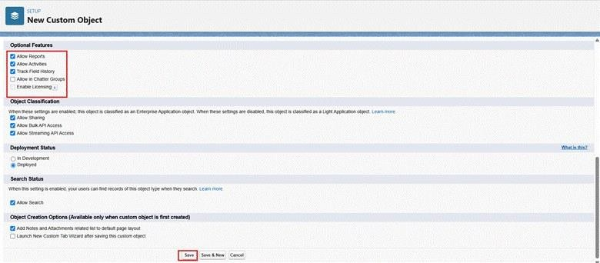
Figure 12: New Custom Object – optional features for the Parcel object
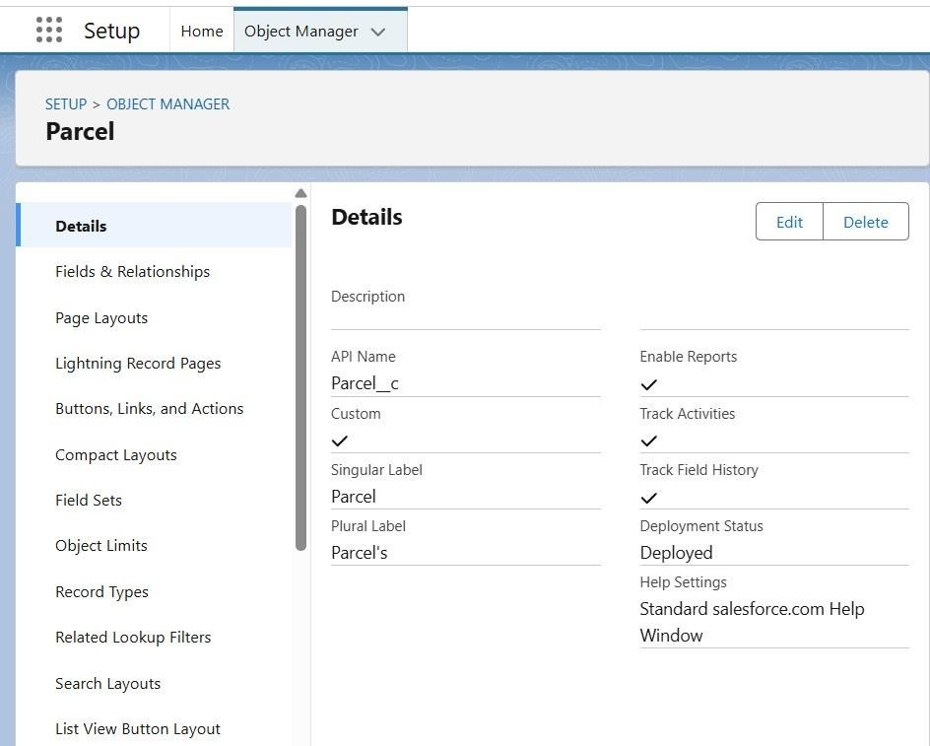
Figure 13: Parcel object details

Creating Delivery Object
- From the Setup page, click on Object Manager.
- Click on Create >> Custom Object.
- Enter the label name as Delivery.
- Enter Plural label name as Deliveries.
- Enter Record Name as Delivery Name.
- Select Data Type as Text: Delivery Name.
- Select Allow Reports.
- Select Allow Search.
- Allow Track Field History.
- Click on Save and New.
Figure 14: New Custom Object – optional features for the Delivery object

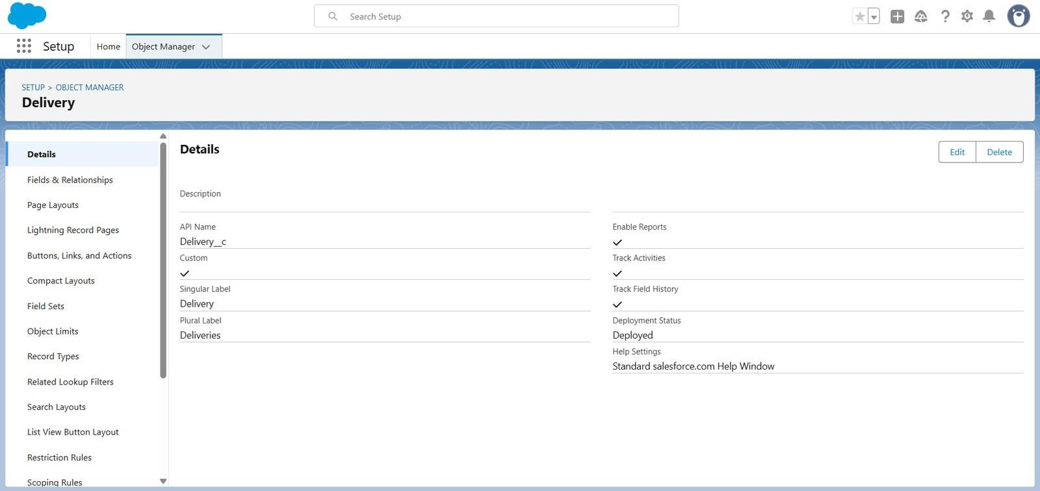
Figure 15: Delivery object details

Creating Sender Object
- From the Setup page, click on Object Manager.
- Click on Create >> Custom Object.
- Enter the label name as Sender.
- Enter Plural label name as Sender’s.
- Enter Record Name as Sender Name.
- Select Data Type as Text: Sender Name.
- Select Allow Reports.
- Select Allow Search.
- Allow Track Field History.
- Click on Save and New.

Figure 16: New Custom Object – optional features for the Sender object
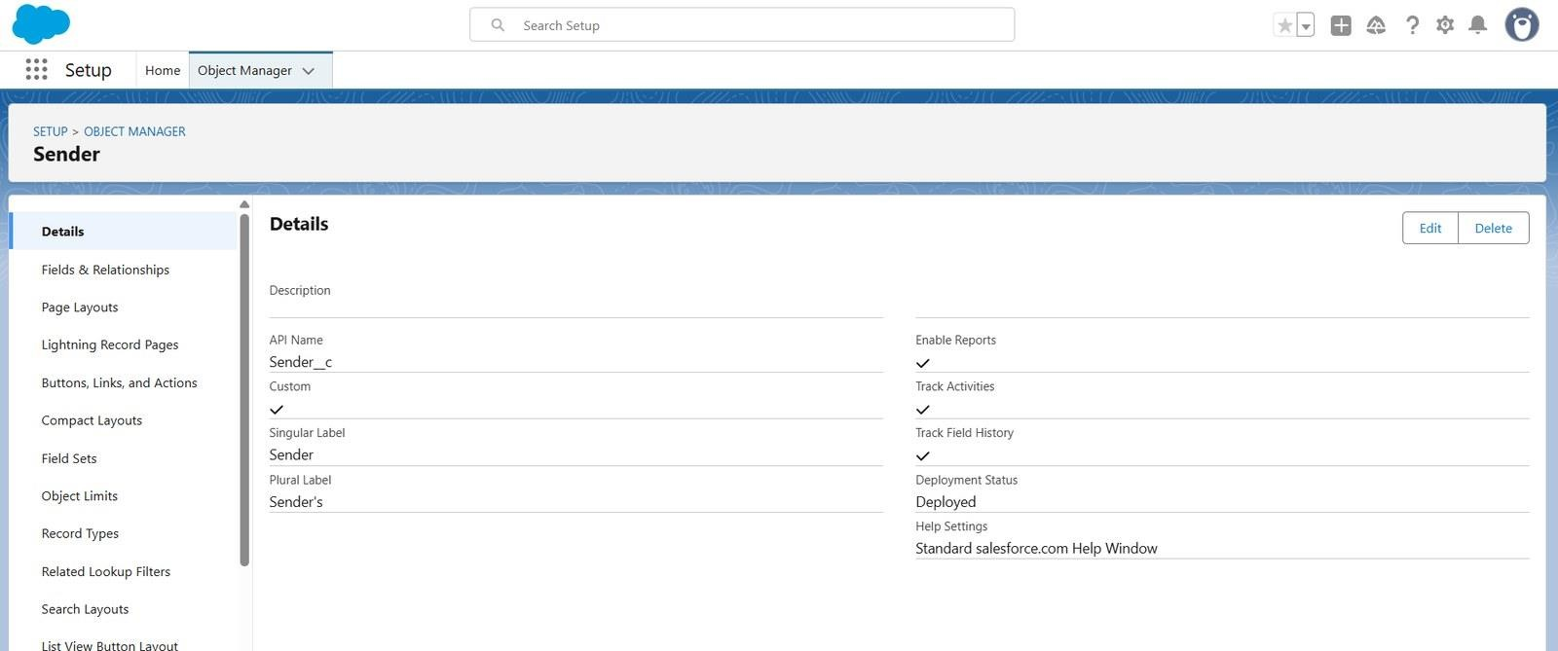
Figure 17: Sender object details

Creating Receiver Object
- From the Setup page, click on Object Manager.
- Click on Create >> Custom Object.
- Enter the label name as Receiver.
- Enter Plural label name as Receiver’s.
- Enter Record Name as Receiver Name.
- Select Data Type as Text: Receiver Name.
- Select Allow Reports.
- Select Allow Search.
- Allow Track Field History.
- Click on Save and New.

Figure 18: New Custom Object – optional features for the Receiver object

Milestone 3 – Tabs

Creating a tab for the Parcel Object
- Go to the Setup page → type Tabs in the Quick Find bar.
- Click on Tabs.
- Click on New (under Custom Object Tabs).
- Select Object (Parcel) >> Select the tab style.
- Click on Next >> (Add to Profiles page) keep it as default >> Click on Next (Add to Custom App) and uncheck Include Tab.
- Make sure that Append tab to the user’s existing personal customizations is checked.
- Click Save.
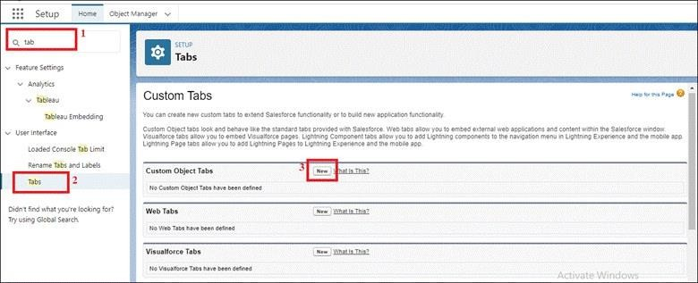
Figure 19: Creating a custom object tab from Setup

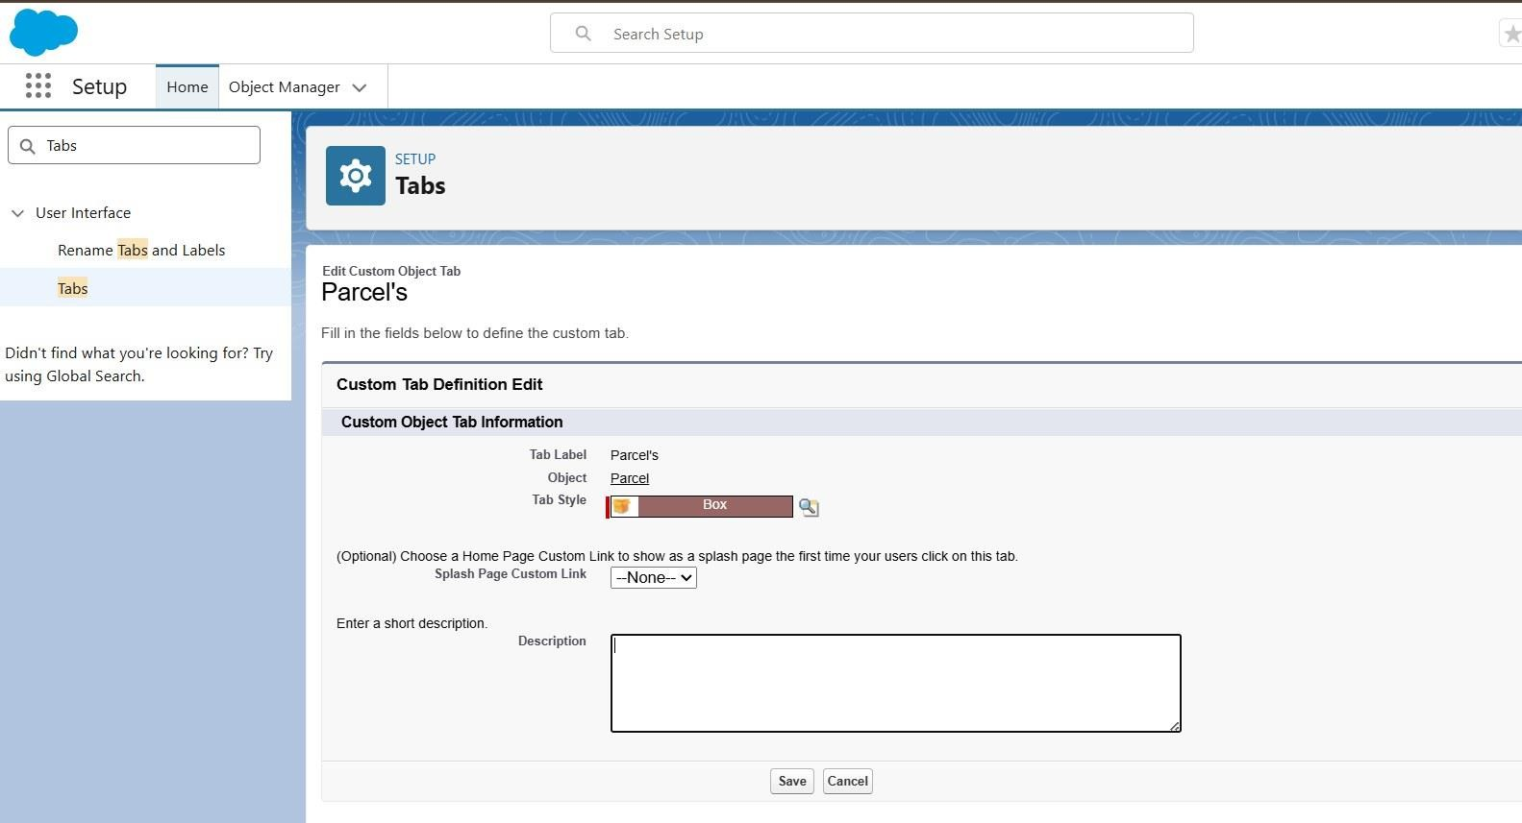
Figure 20: Custom object tab definition for the Parcel object

More Tab Creation
- Go to Setup → type Tabs in the Quick Find box.
- Click Tabs under the User Interface section.
- Click New under Custom Object Tabs.
- Select the object (Delivery, Sender, or Receiver) → choose a Tab Style.
- Click Next → keep the Add to Profiles settings as default → click Next.
- On the Add to Custom Apps page, uncheck “Include Tab.”
- Ensure Append tab to the user’s existing personal customizations is checked.
- Click Save and repeat the steps for each object (Delivery, Sender, Receiver).

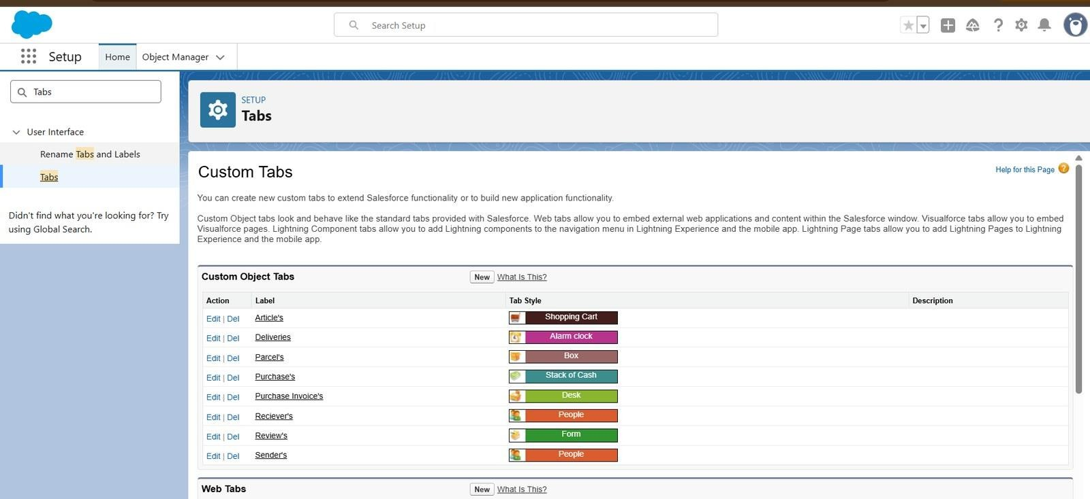
Figure 21: Custom object tabs list

Milestone 4 – Fields & Relationships
Create fields and relationships for the custom objects created in the previous milestone.

Creating Fields and Relationships for Parcel Object
Beside the Quick Find box, click on Object Manager, then search for and select the Parcel object.

Field 1: Parcel ID
- Go to Fields & Relationships → click New.
- Enter Data Type: Auto Number → Display Format P-{000}.
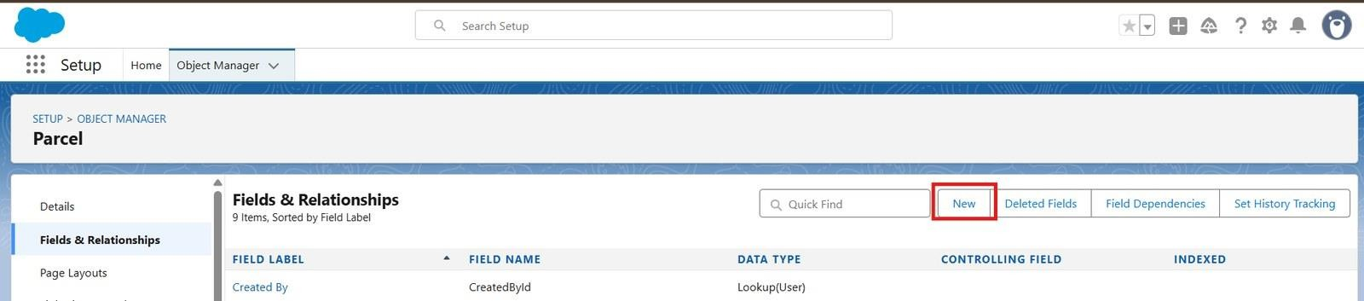
Figure 22: Parcel object – Fields & Relationships

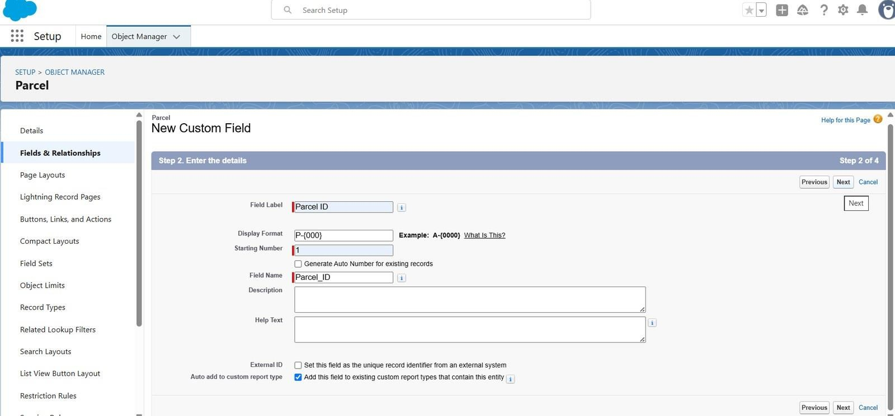
Figure 23: Creating the Parcel ID auto-number field
- Click Next → Next → Save & New.

Follow the same steps to create the remaining fields (Status, Weight, Estimated Delivery, Sender) of the Parcel object (API Name: Parcel c) as listed in the table below.
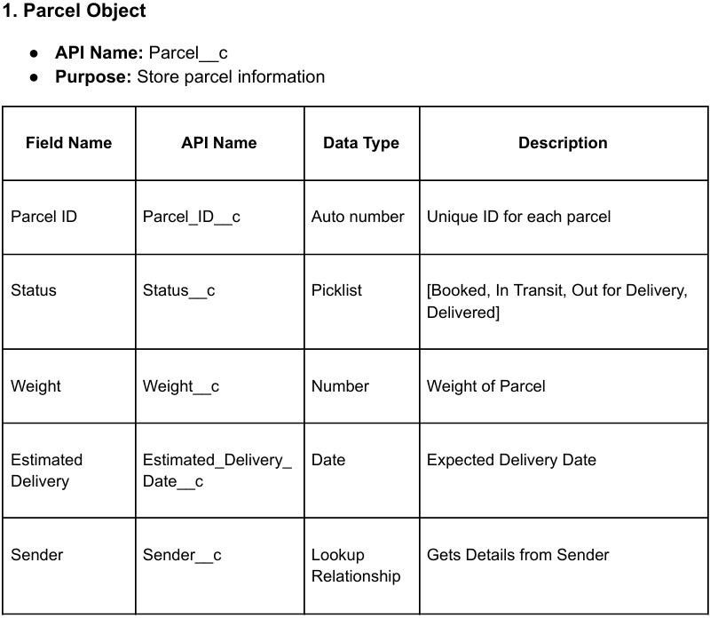

Figure 24: Parcel object fields

Creating Fields and Relationships for Delivery Object
Beside the Quick Find box, click on Object Manager, then search for and select the Delivery object.

Field 1: Current Location
- Go to Fields & Relationships → click New.

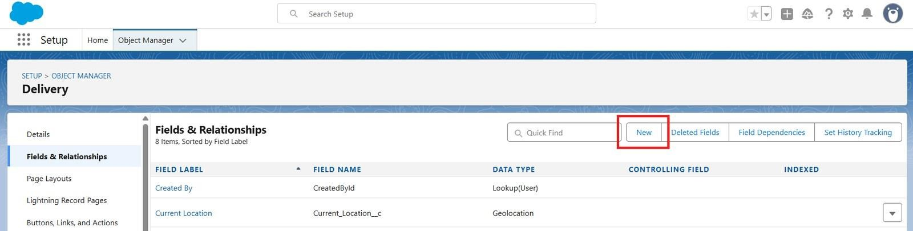
Figure 25: Delivery object – Fields & Relationships
- Choose Data Type: Geolocation → click Next. Field Label: Current Location. Click Next
→ Next → Save & New.
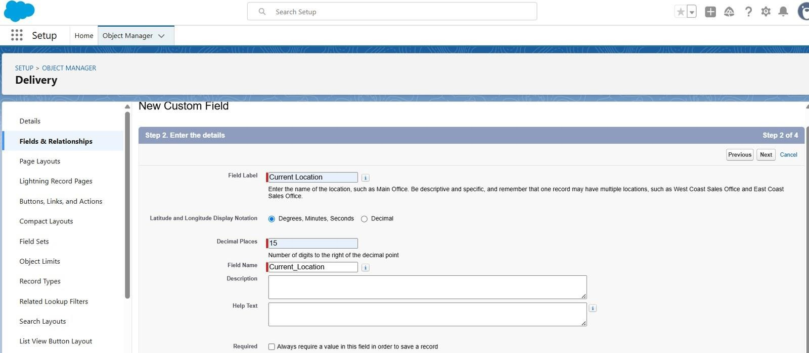
Figure 26: Creating the Current Location geolocation field

Follow the same steps to create the remaining fields (Estimated Delivery, Sender, Parcel) of the Delivery object as listed in the table below.
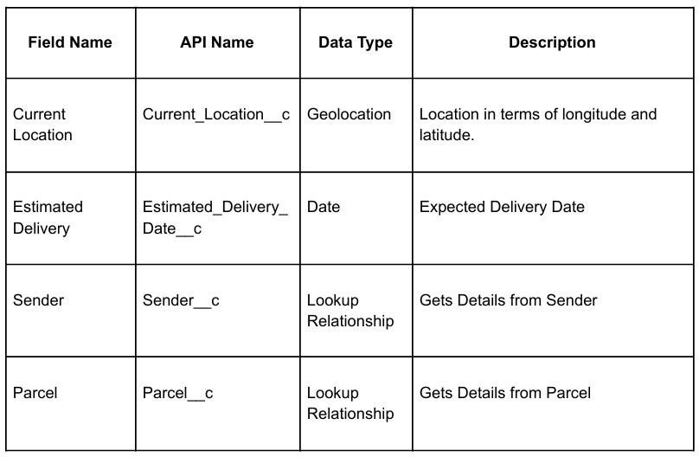

Figure 27: Delivery object fields

Creating Fields and Relationships for Sender Object
Beside the Quick Find box, click on Object Manager, then search for and select the Sender object.

Field 1: Sender Address
- Go to Fields & Relationships → click New.
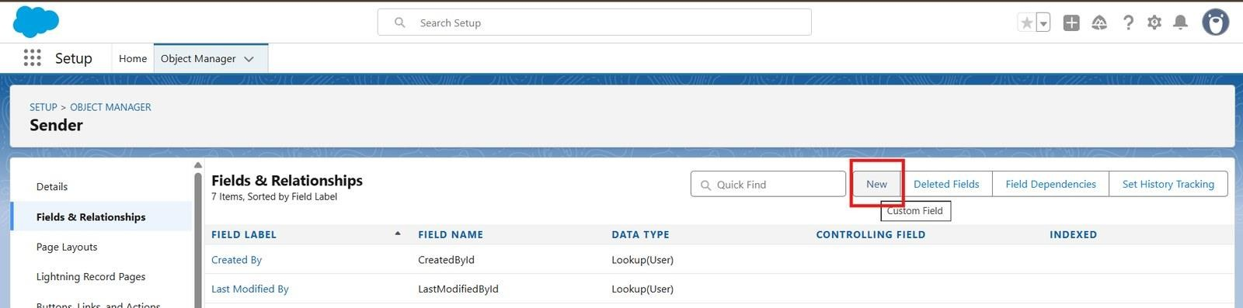
Figure 28: Sender object – Fields & Relationships
- Choose Data Type: Geolocation → click Next. Field Label: Sender Address. Click Next
→ Next → Save & New.

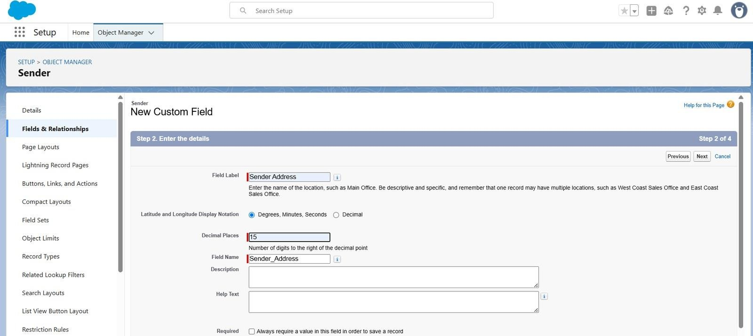
Figure 29: Creating the Sender Address geolocation field
Follow the same steps to create the remaining fields (Sender Contact, Sender Email) of the Sender object as listed in the table below.
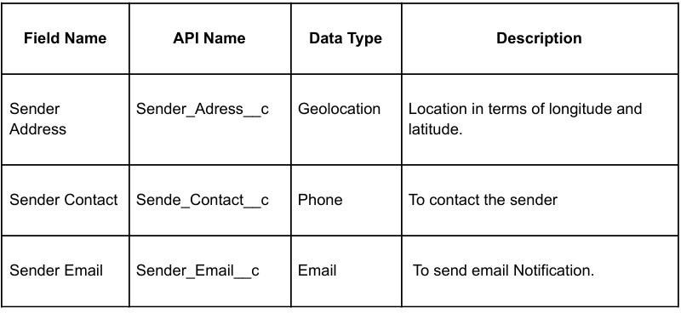
Figure 30: Sender object fields

Creating Fields and Relationships for Receiver Object
Beside the Quick Find box, click on Object Manager, then search for and select the Receiver object.

Field 1: Receiver Address
- Go to Fields & Relationships → click New.

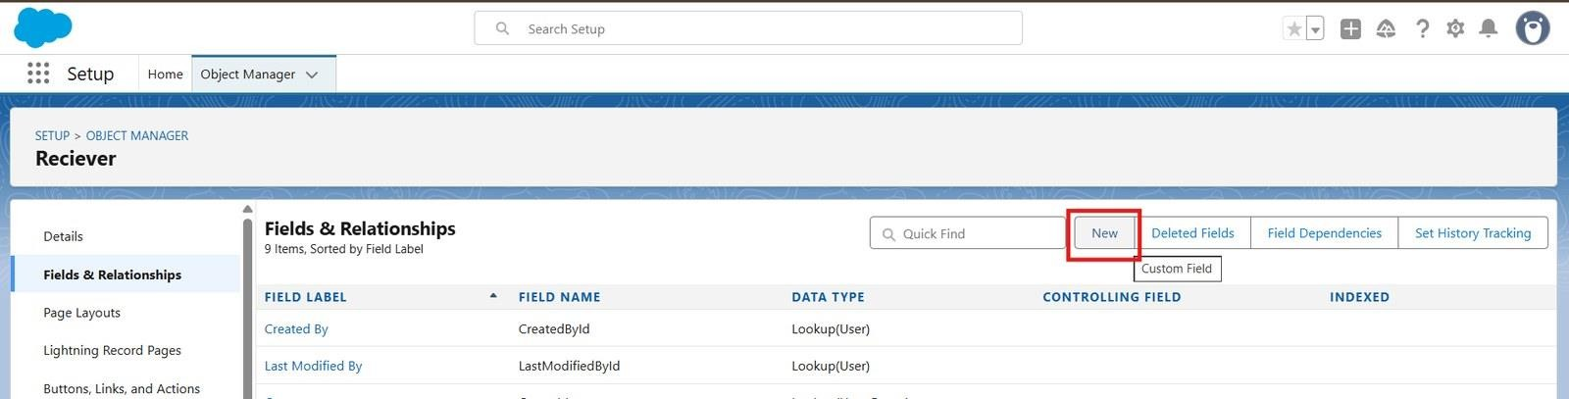
Figure 31: Receiver object – Fields & Relationships
- Choose Data Type: Geolocation → click Next. Field Label: Receiver’s Address. Click Next → Next → Save & New.
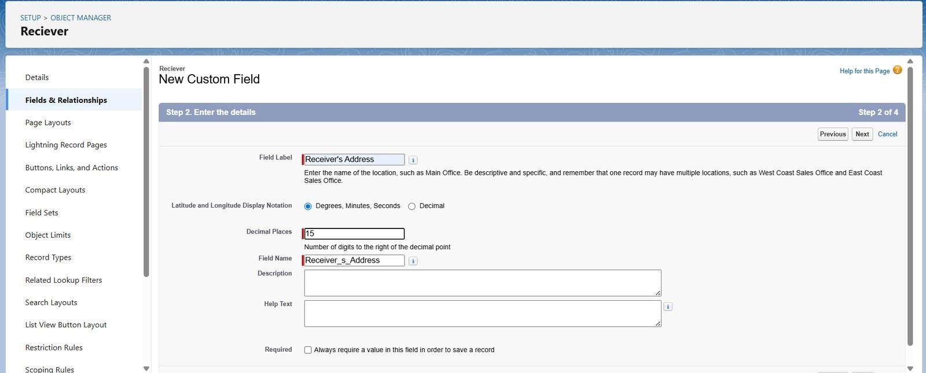
Figure 32: Creating the Receiver’s Address geolocation field

Follow the same steps to create the remaining fields (Receiver Contact, Receiver Email, Sender, Parcel) of the Receiver object as listed in the table below.
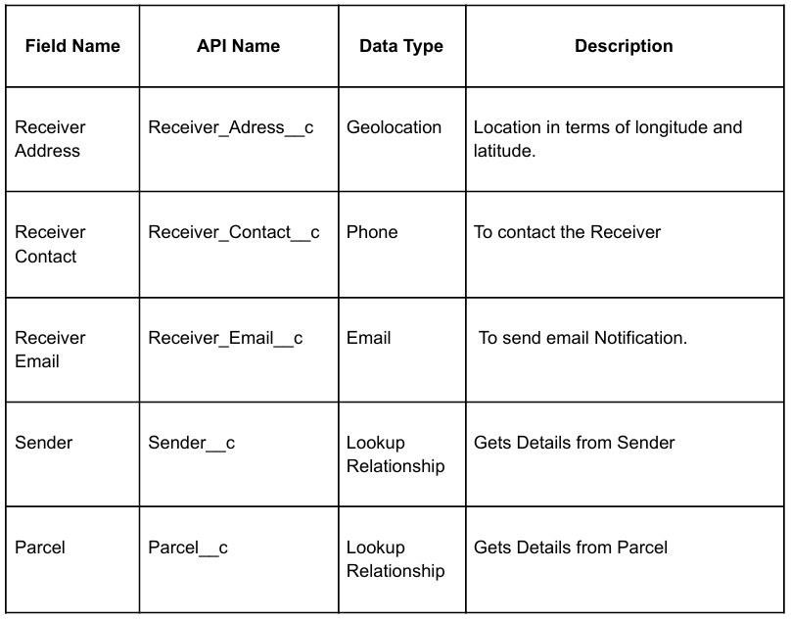
Figure 33: Receiver object fields

Object Relationships
- Parcel → Sender (Lookup): a parcel gets its sender details from the Sender record.
- Delivery → Parcel and Sender (Lookup): a delivery record is linked to its parcel and sender.
- Receiver → Parcel and Sender (Lookup): a receiver record links both ends of a shipment.

Milestone 5 – Prompt Builder
Designing prompts for agent building. In Salesforce, go to Setup.
- In the Quick Find box, type Prompt Builder (Einstein Generative AI → Prompt Builder).
- Click New Prompt Template and choose the Record Summary template type.

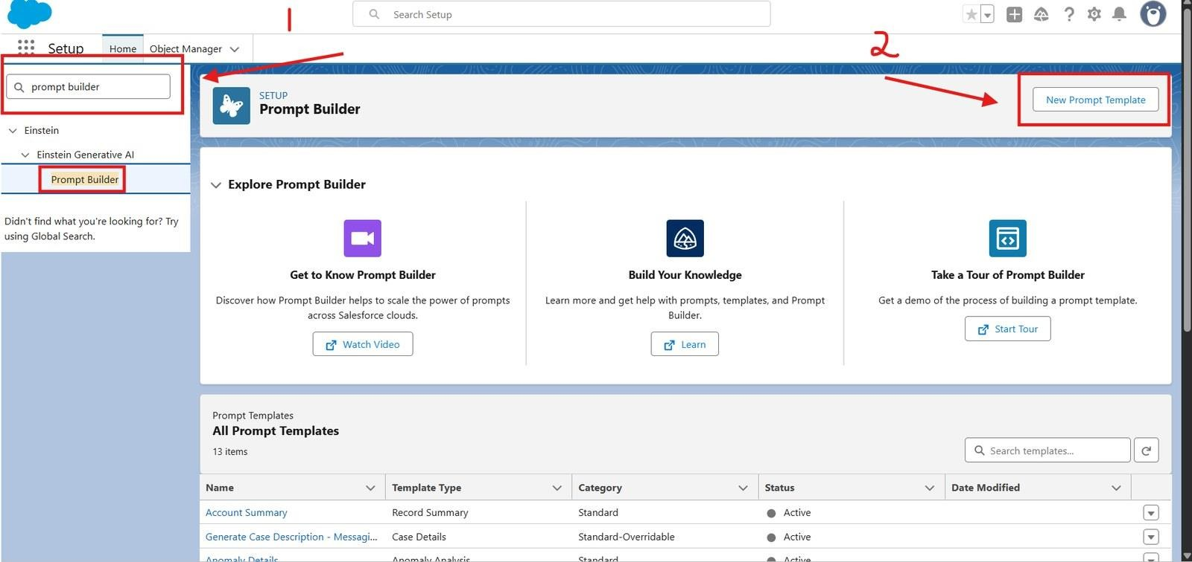
Figure 34: Prompt Builder – New Prompt Template
- Select the object type Parcel (Parcel c) and click Start from Scratch.
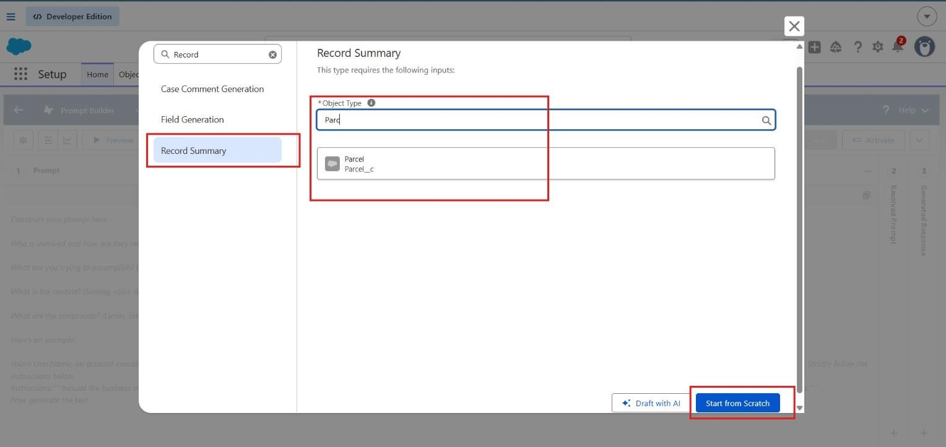
Figure 35: Record Summary template – selecting the Parcel object
- Enter the details:
  - Label: Retrieve Parcel Details
  - API Name: Retrieve_Parcel_Details
  - Description: Retrieves parcel details where Parcel_ID matches the user input.
- Enter the Prompt Template content. In the Prompt Template Text area, enter the following:
Retrieve details from Parcel c where Parcel_ID c matches user input. Return response in this format:

Parcel Tracking Update
- Parcel Name: {!$Input:Parcel c.Name}
- Parcel ID: {!$Input:Parcel c.Parcel_ID c}
- Status: {!$Input:Parcel c.Status c}
- Weight: {!$Input:Parcel c.Weight c}
- Estimated Delivery Date: {!$Input:Parcel c.Estimated_Delivery_Date c}
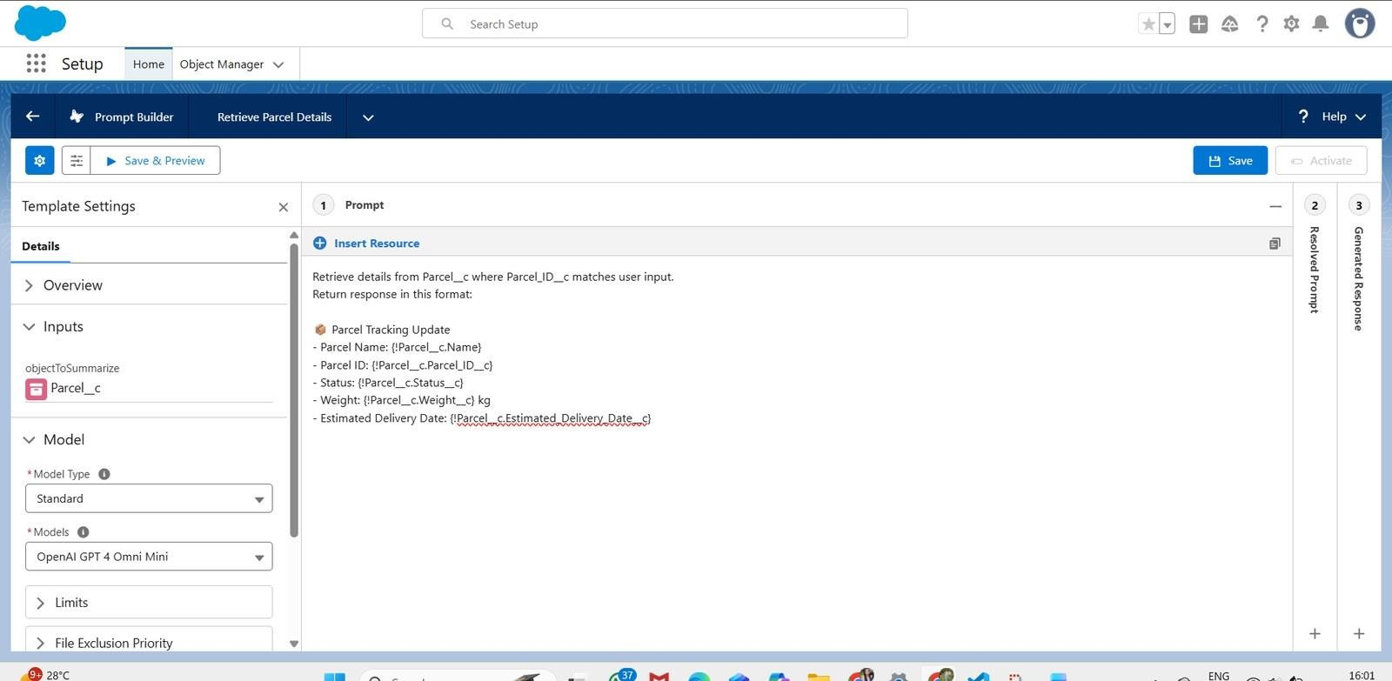
Figure 36: Retrieve Parcel Details prompt template in Prompt Builder
- Add Resource Mapping: scroll down to the Resources / Insert Resources section.
  - Click Insert Resource → choose Object → select Parcel c.
  - Add the fields Name, Parcel_ID c, Status c, Weight c and Estimated_Delivery_Date c.
  - Click Insert Resource (or Add) for each one.
- Click Save.
- Then click Activate to make this Prompt Template available for your agent or Flow.

Testing the Prompt
- Open the prompt Preview and select a Parcel record as the input.
- The resolved prompt and the generated response show the Parcel Tracking Update (Parcel Name, Parcel ID, Status, Weight and Estimated Delivery Date) taken from the Parcel record.

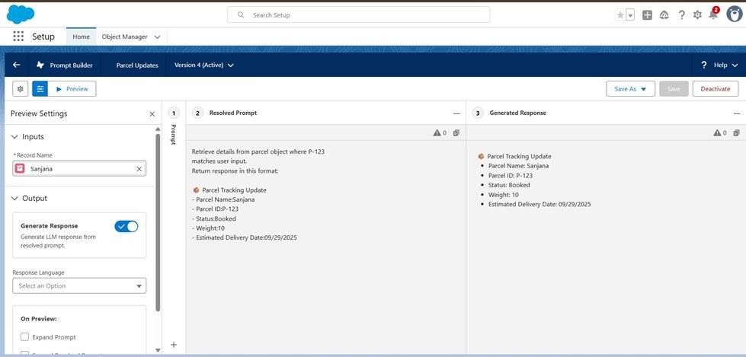
Figure 37: Prompt preview – resolved prompt and generated response

Milestone 6 – Flows
Create a Flow that captures the prompt response and returns it to the agent. Go to Setup → search Flows → click New Flow.
- Choose Autolaunched Flow (No Trigger) → click Create.
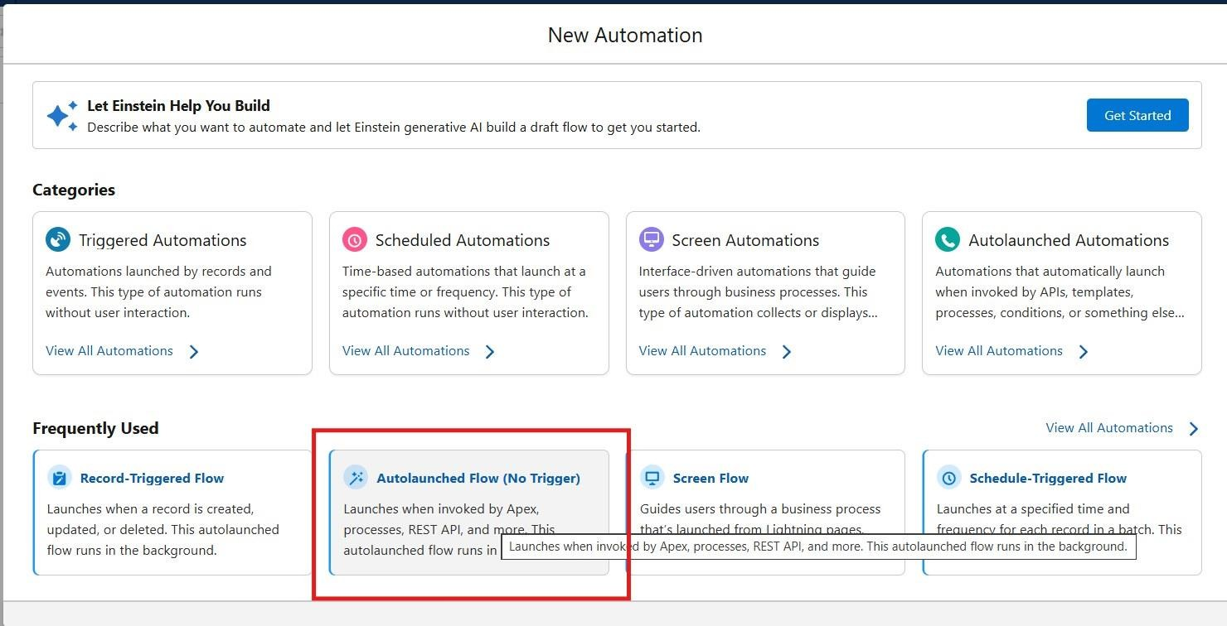
Figure 38: New Automation – Autolaunched Flow (No Trigger)
- Add Input Variables (to allow the agent to pass values): click New Resource → Variable → Available for Input.

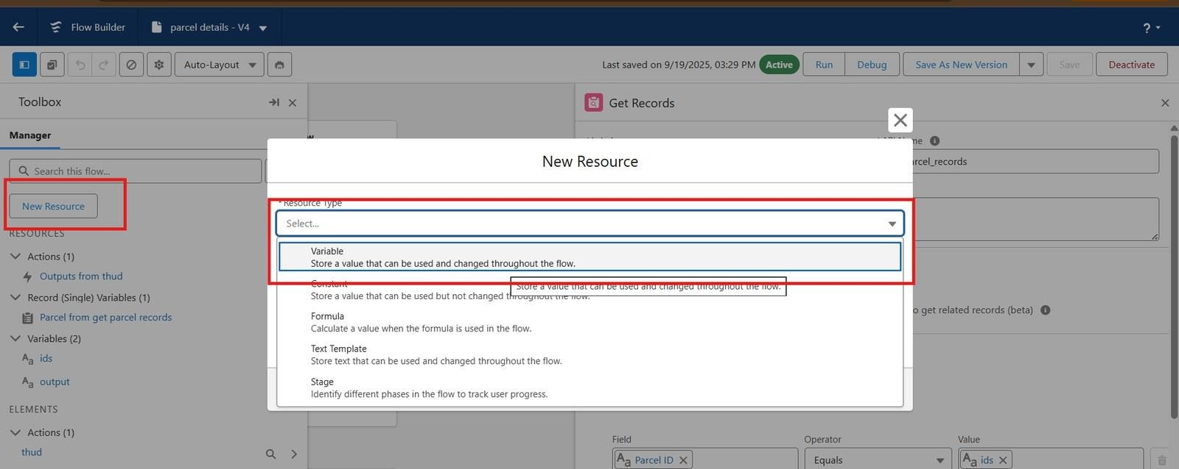
Figure 39: Creating a Flow variable resource
  - ids → Data Type: Text → Available for Input.
  - output → Data Type: Text → Available for Output.
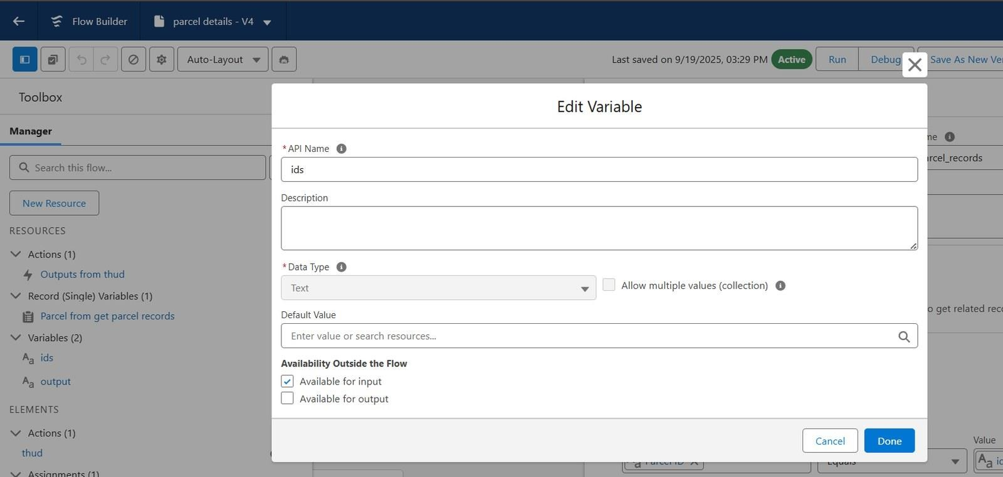
Figure 40: Edit Variable – ids (available for input)

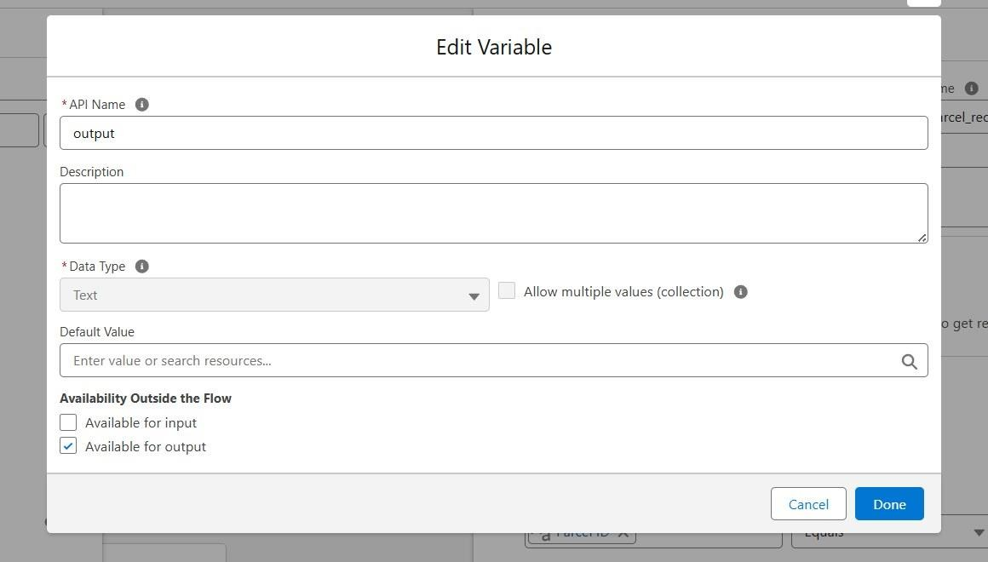
Figure 41: Edit Variable – output (available for output)
- Click on the Add icon to add Element: Get Records → Label: Get Parcel Records.
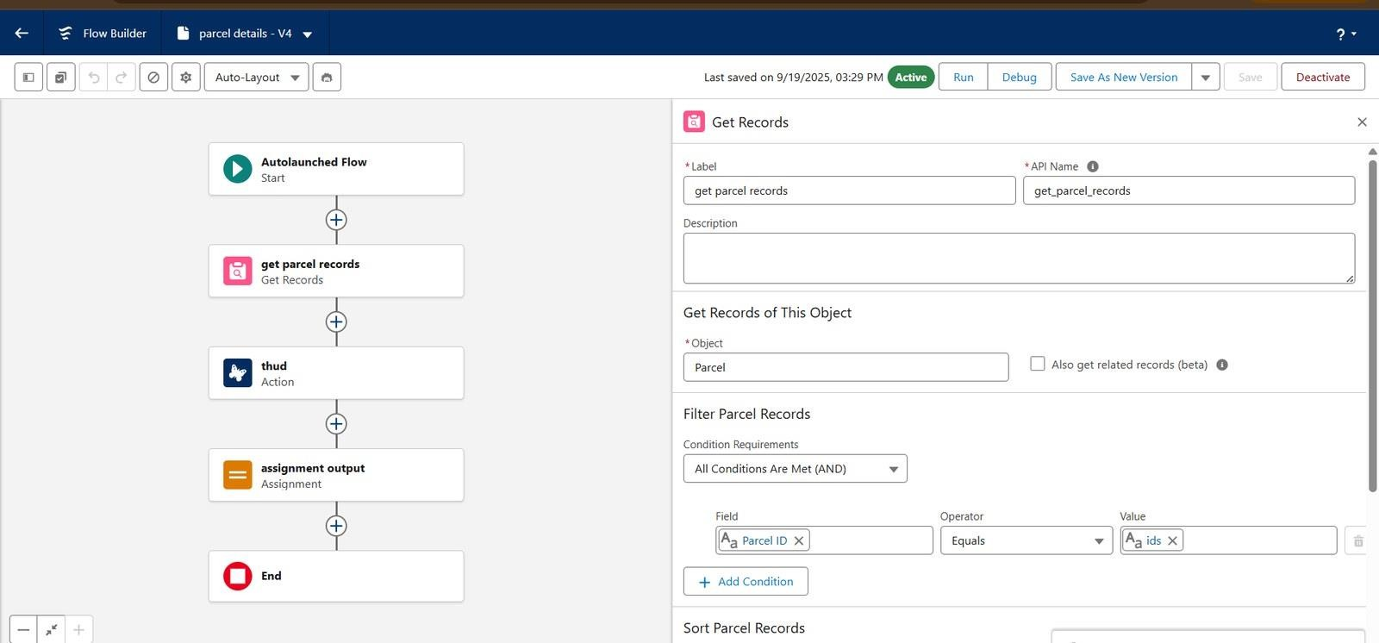
Figure 42: Get Records element – Parcel filtered by Parcel ID
  - Object: Parcel
  - Field = Parcel_ID c
  - Operator = Equals
  - Value = ids
- Element: Action. Find and select the Retrieve Parcel Details prompt template action.

  - Label: Parcel Updates.
  - Object To Summarize: Parcel from Get Parcel Records.
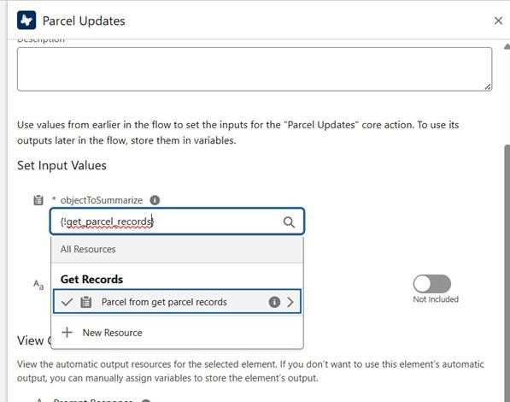
Figure 43: Parcel Updates action – Object To Summarize
- Element: Assignment.
  - Label: Assignment Outputs.
  - Variable = output
  - Operator = Equals
  - Value = Outputs from Action > Prompt Response

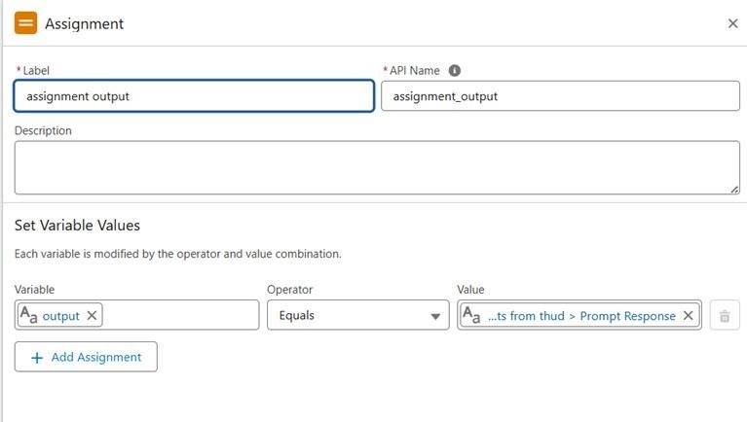
Figure 44: Assignment element – storing the prompt response in output
- Connect Start → Get Records → Action → Assignment → End.
- Save Flow → Name: Parcel Details.
- Activate the Flow.
- Once the Flow is saved, go back to the Flows list, click the drop-down near the Flow that was just created and click Edit Access.
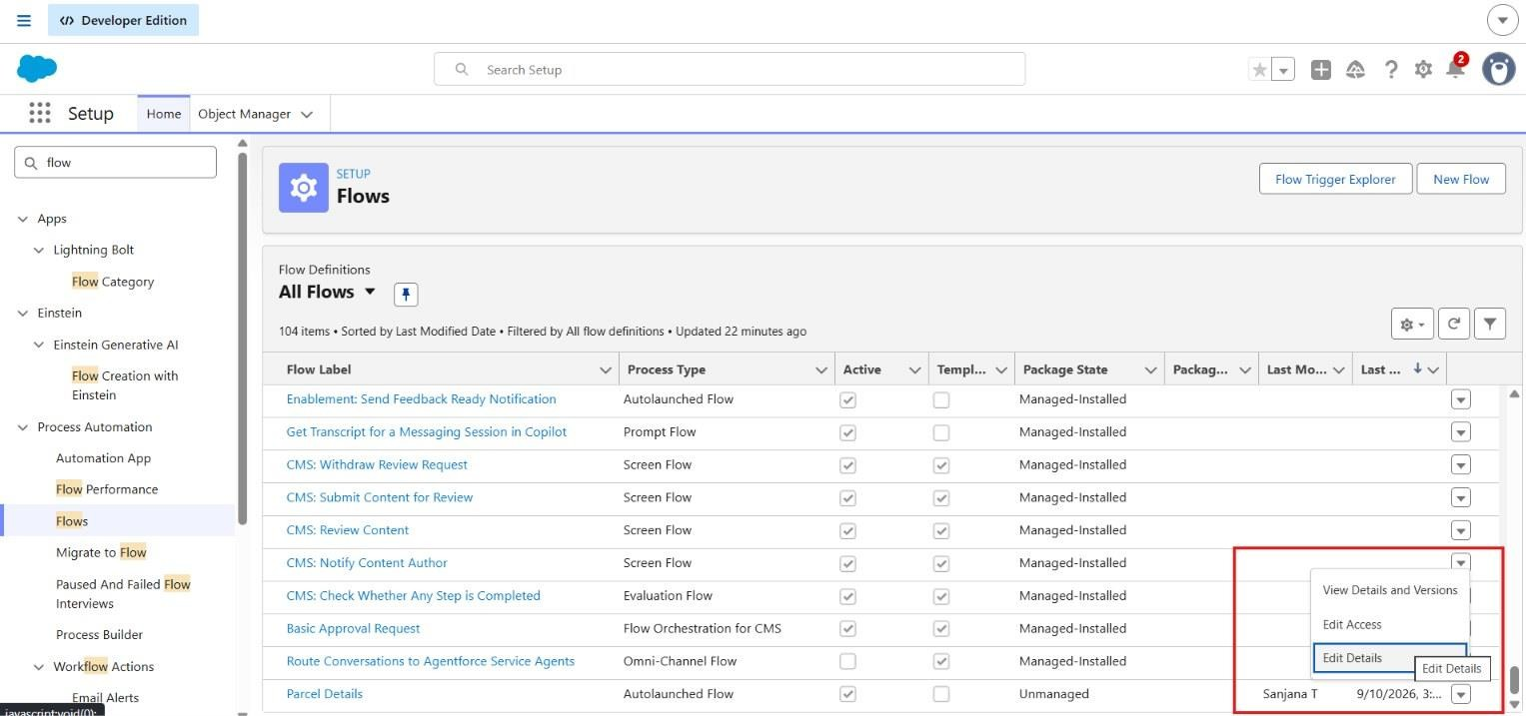
Figure 45: Flows list – Parcel Details Flow
- On the top, look for Flow User Access, then assign the available profiles and click Save.

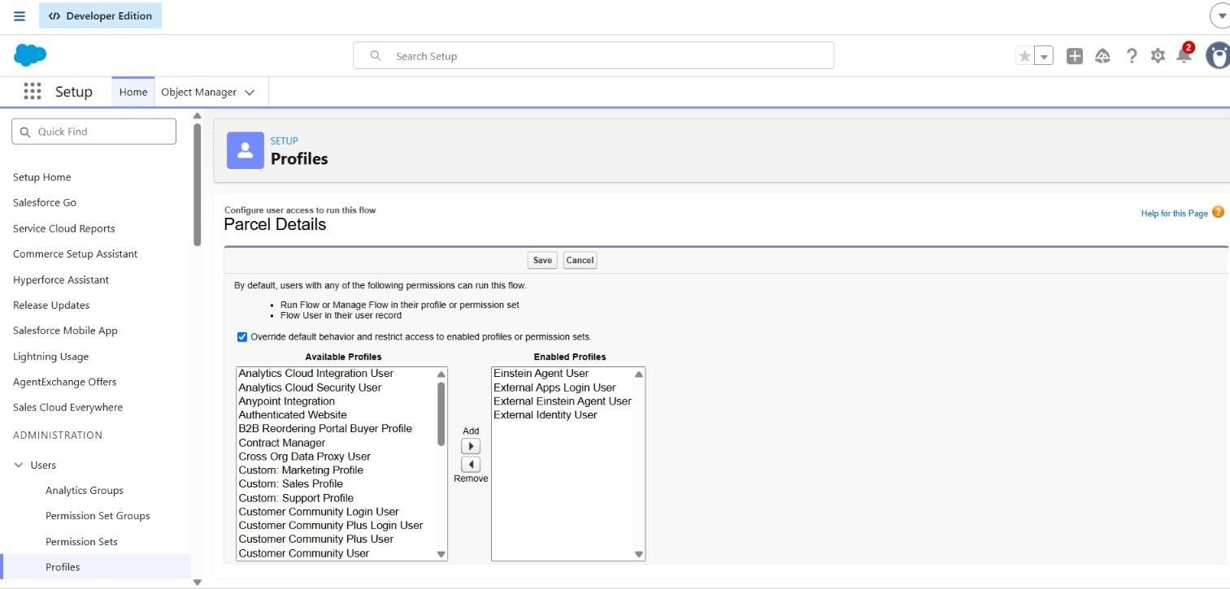
Figure 46: Flow User Access – enabled profiles for the Parcel Details Flow

Phase 3: UI/UX Development & Customization
To enable agents to efficiently manage parcel operations and ensure secure access control using permission sets and AI-driven agent experiences built with Agentforce.

Milestone 1 – Creating Permission Sets
In the Quick Find box (left side), type Permission Sets.
- Click Permission Sets under Users.
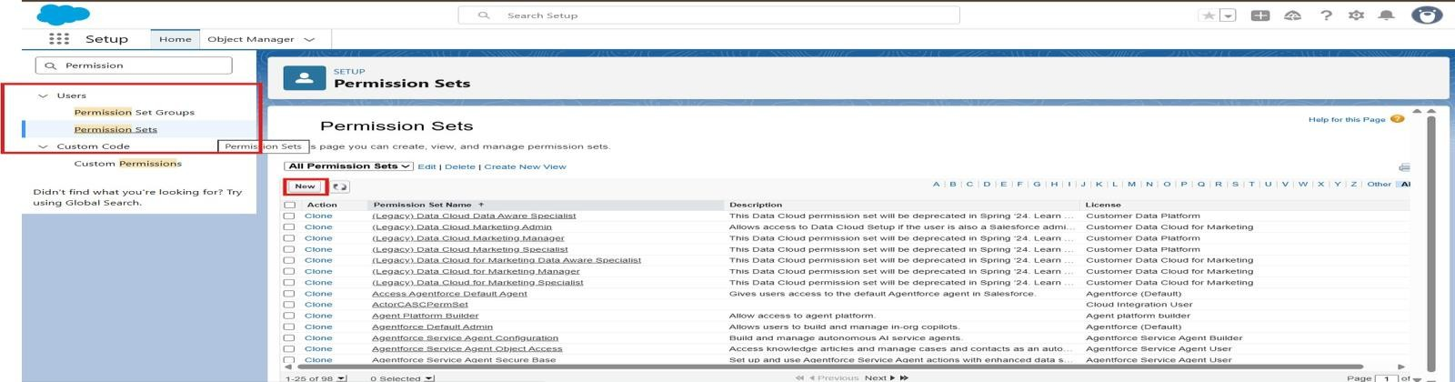
Figure 47: Permission Sets page in Setup
- Click the New button.
- Enter the following details: Label: Swift Ship; API Name: auto-fills; License: Einstein Agent.
- Click Save.

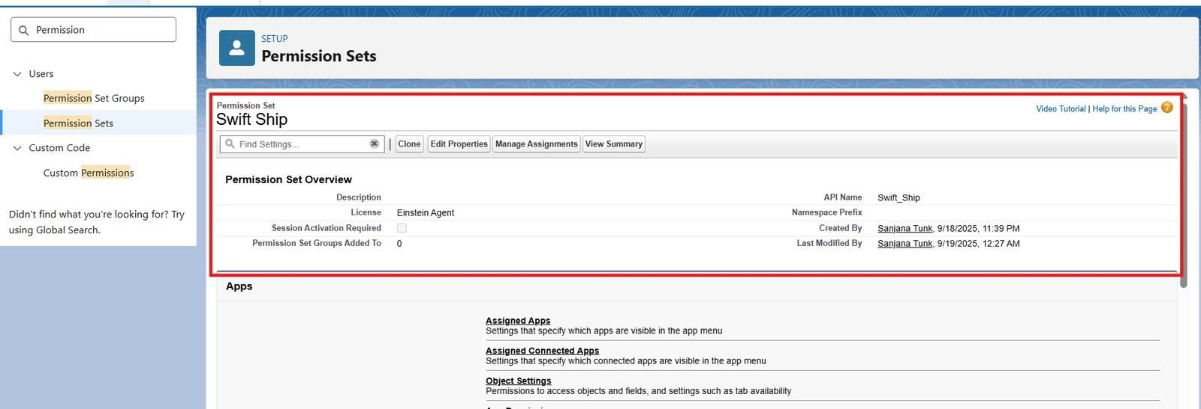
Figure 48: Swift Ship permission set overview
- Inside the Permission Set page → under Apps, click Object Settings.
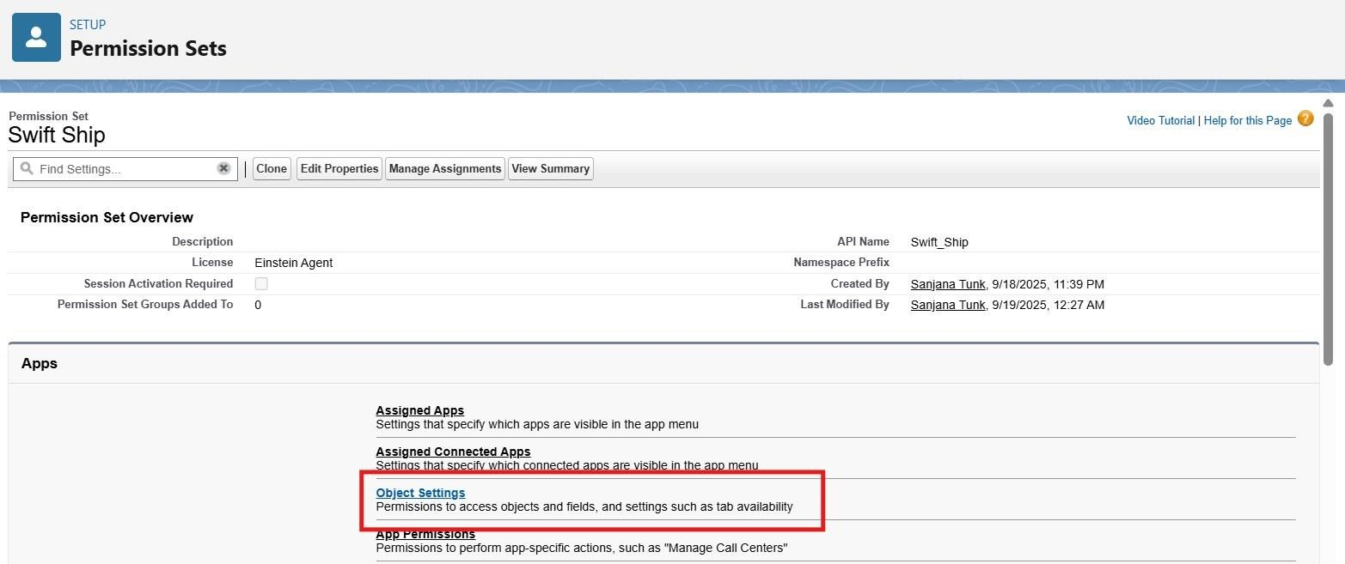
Figure 49: Permission set – Object Settings
- Search and click each object one by one, then click Edit.
- Enable Read, Create and Edit (Delete is optional, if agents should remove records).
- Under Field Permissions, ensure at least Visible is checked for all key fields.
- Click Save after each object.

Parcel c
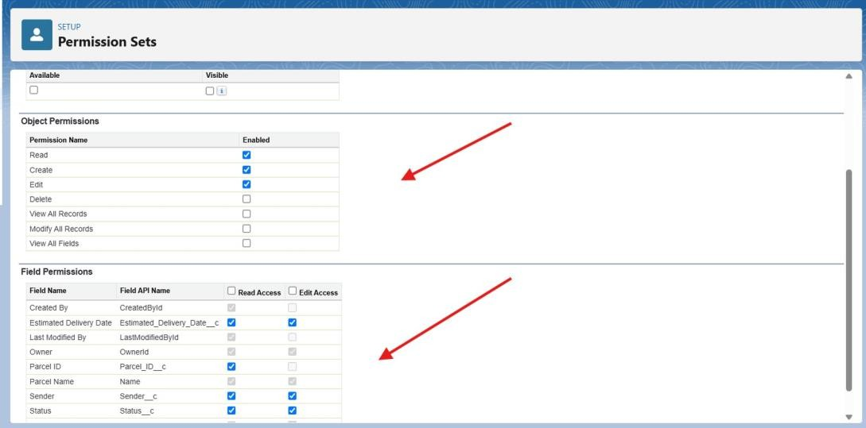
Figure 50: Object and field permissions – Parcel c

Delivery c
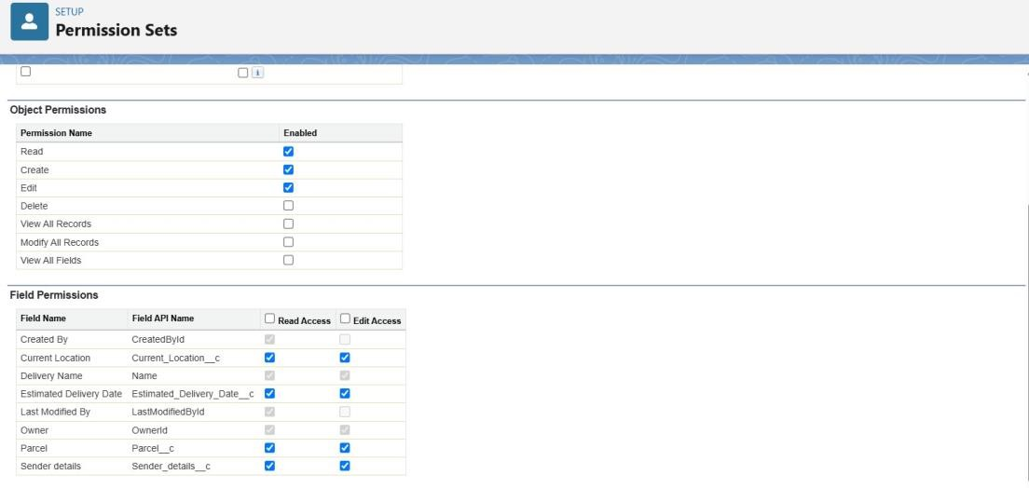
Figure 51: Object and field permissions – Delivery c

Sender c
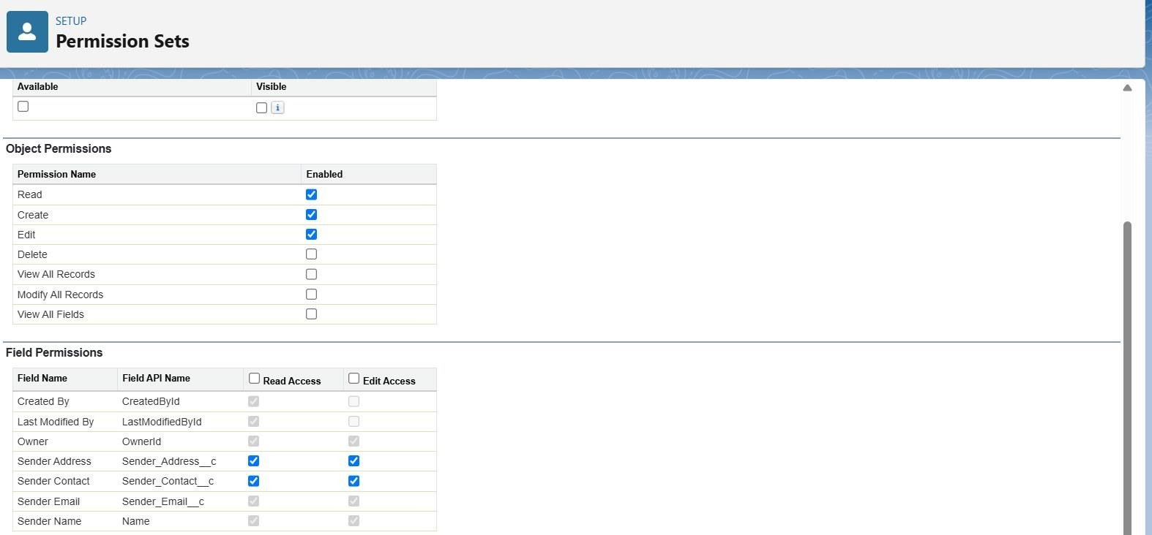
Figure 52: Object and field permissions – Sender c

Receiver c
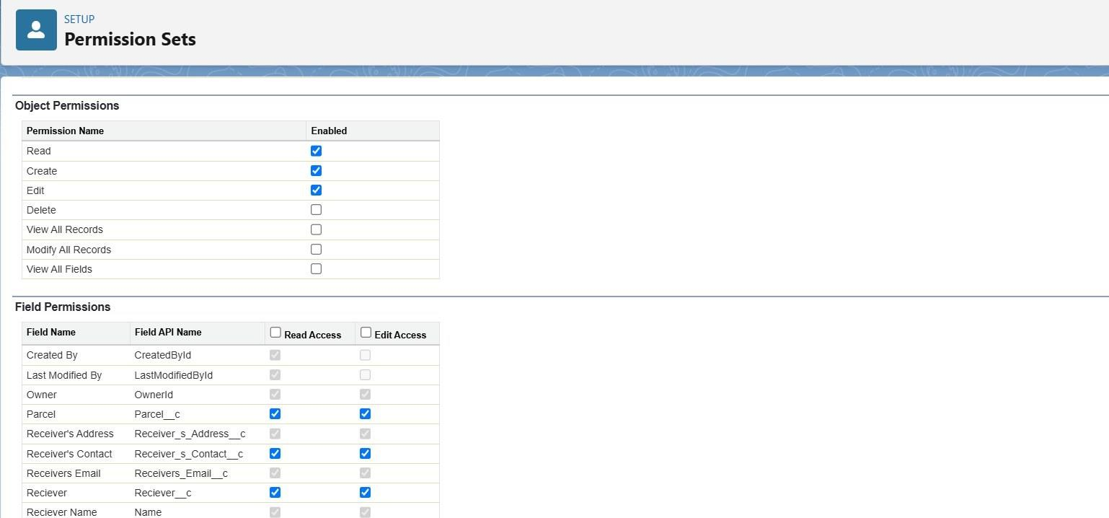
Figure 53: Object and field permissions – Receiver c

Milestone 2 – Assigning Permissions to the Agent User
In the Quick Find box on the left, type Users.
- Click Users under the Users section.
- Open the Agent User record: from the list of users, find the Einstein Service Agent user that represents the agent and click its Full Name to open the record.

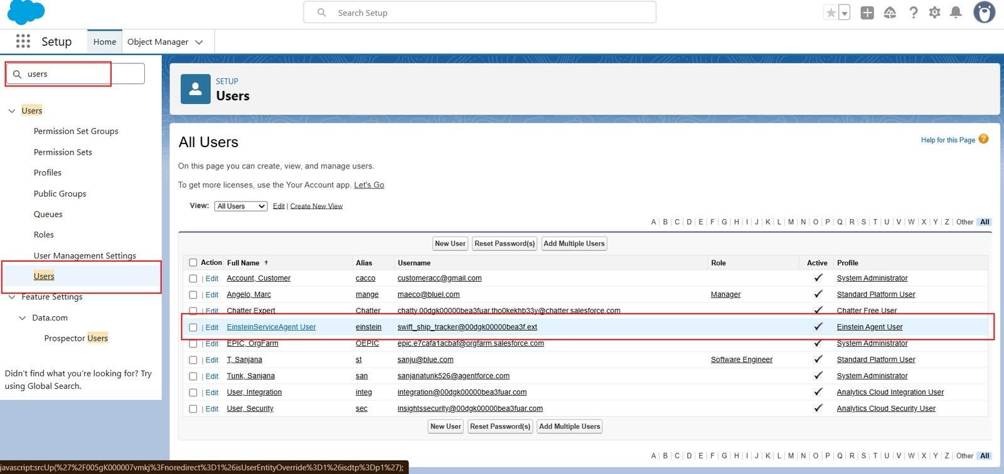
Figure 54: All Users list – EinsteinServiceAgent User
- Scroll down to the section named Permission Set Assignments.
- Click the Edit Assignments button.
- On the left side (Available Permission Sets), find and select the Swift Ship permission set.
- Click the Add button to move it to the right-side list (Enabled Permission Sets).
- Click Save.
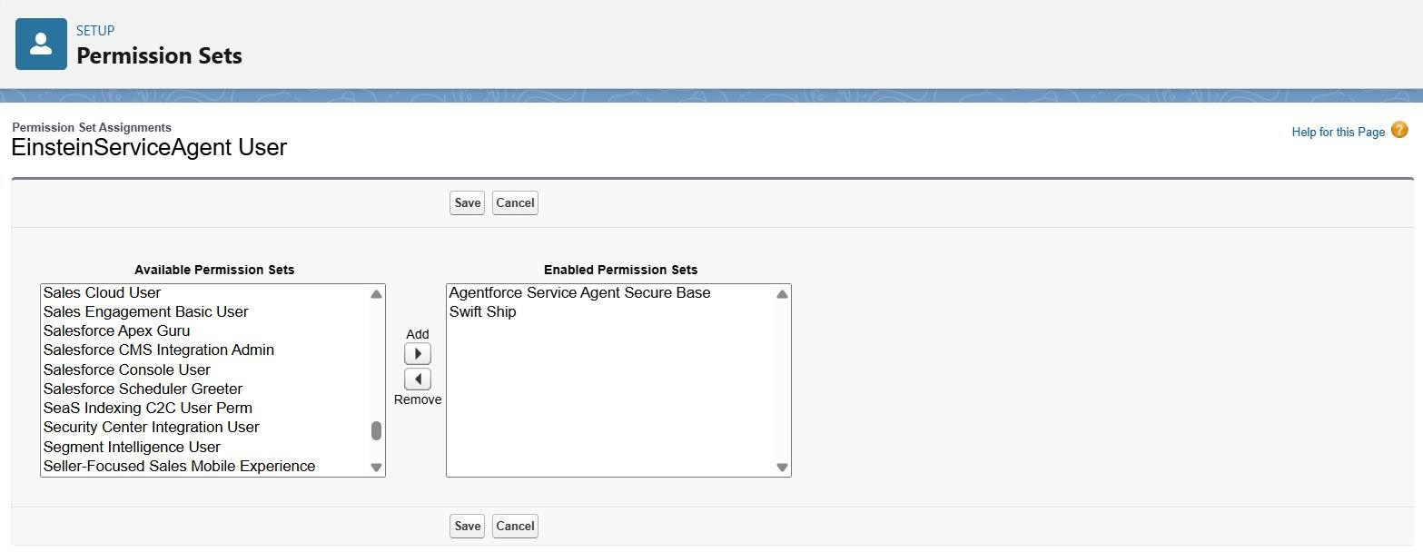
Figure 55: Edit Assignments – enabling the Swift Ship permission set

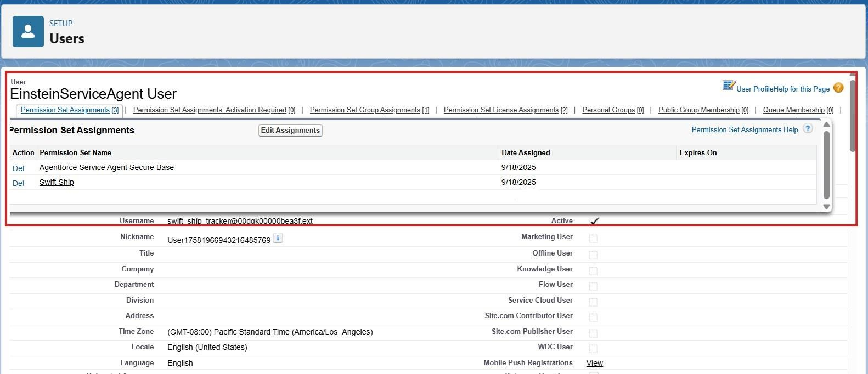
Figure 56: Permission set assignments of the Einstein Service Agent user

Milestone 3 – Org Setup for Agentforce

Enable Salesforce Default Agent from Salesforce Go
- From the Quick Find box, search “Salesforce Go” and click on it.
- Search for Default Agent → click Get Started and turn it on.
- Refresh the page.

Enable Einstein Setup
Go to Setup → Quick Find → Einstein Setup. Open Einstein Setup and click Get Started if prompted. Toggle On these key services:
  - Turn On Einstein
  - Global Languages
  - Deploy Prompt Templates
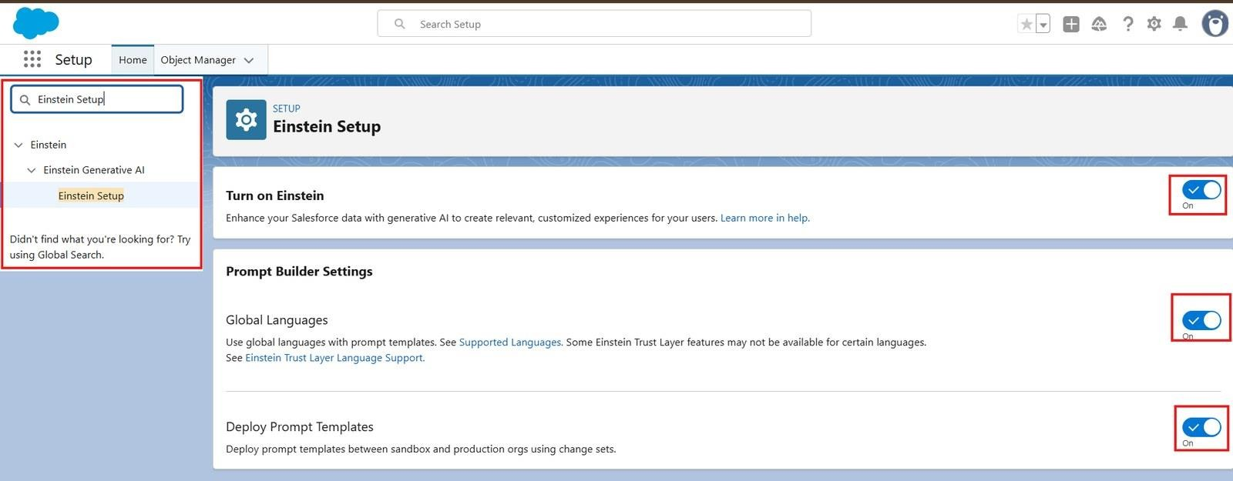
Figure 57: Einstein Setup – Einstein, Global Languages and Deploy Prompt Templates enabled

- Refresh your browser page.
- Go to Setup → Quick Find → Agentforce Agents and toggle On: Agentforce and Enable Agentforce Default Agent.
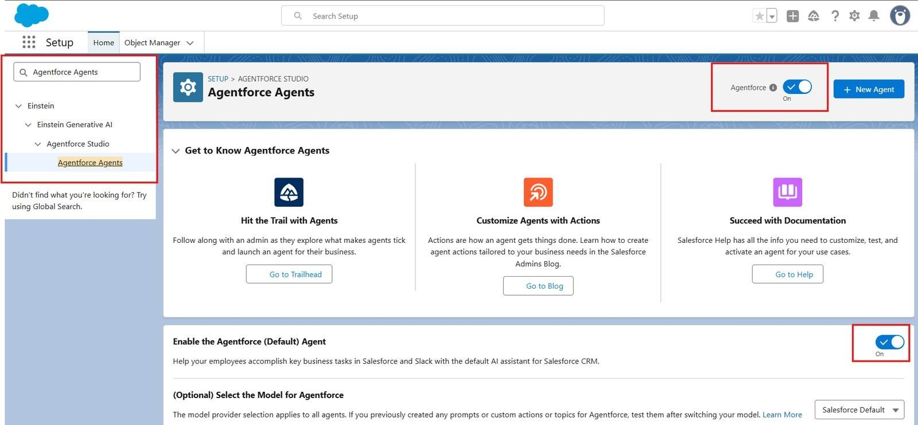
Figure 58: Agentforce Agents – Agentforce and Default Agent enabled

Milestone 4 – Building the Agent
- In Setup, search for Agentforce Agents in Quick Find.
- Click Agentforce Agents, then click on the default Agent, then click on Open in Builder.
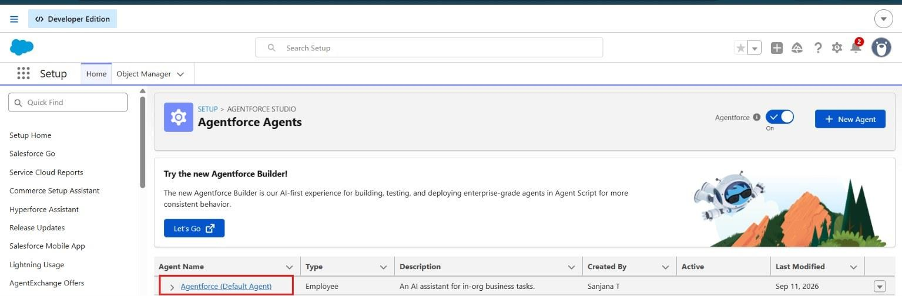
Figure 59: Agentforce Agents list

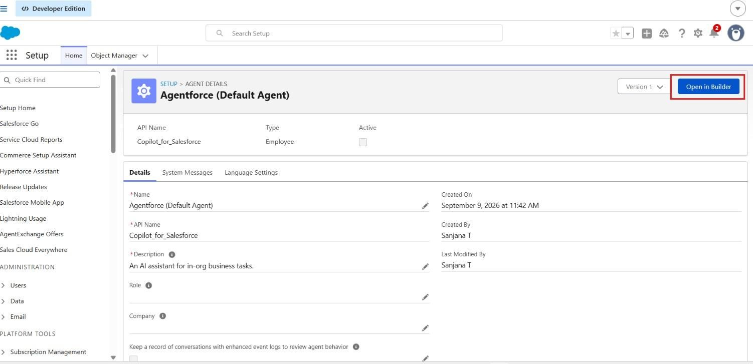
Figure 60: Agentforce (Default Agent) details – Open in Builder

Assign Subagents to the Agent
- On the Subagents panel click New, then click New Subagent.
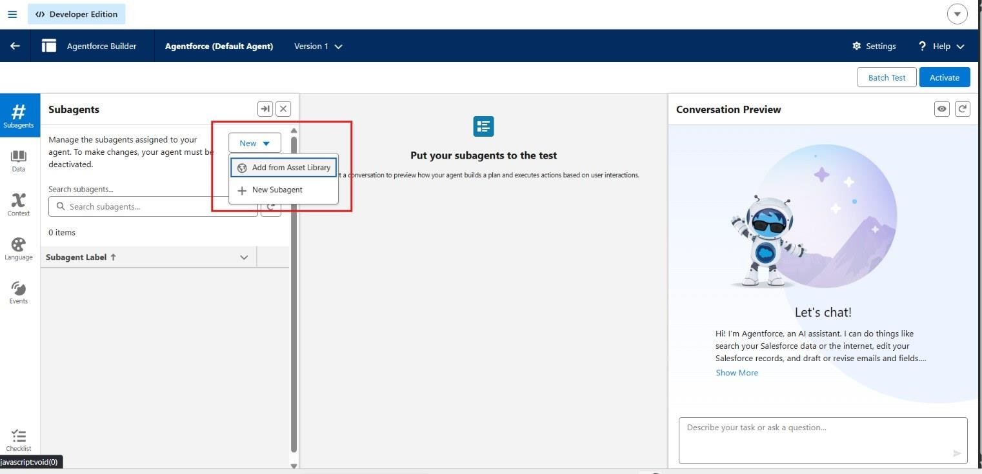
Figure 61: Agentforce Builder – creating a new subagent
- Create a new subagent.
- Fill in the details: “The Agent should give the parcel details related to the user, by asking for the parcel Id”.

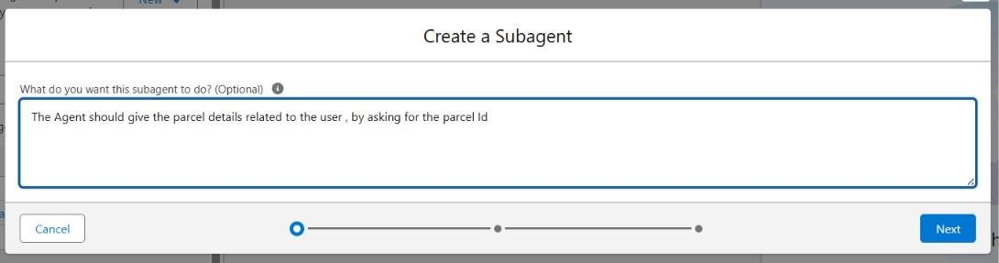
Figure 62: Create a Subagent dialog

Adding Actions to Agentforce Assets
While still in Agent Builder, open the topics’ actions (Agentforce Asset Library).
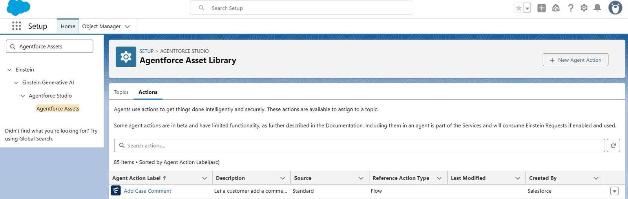
Figure 63: Agentforce Asset Library – Actions
- Click on New Agent Action.
- For Action type, click on Flow, then Next.

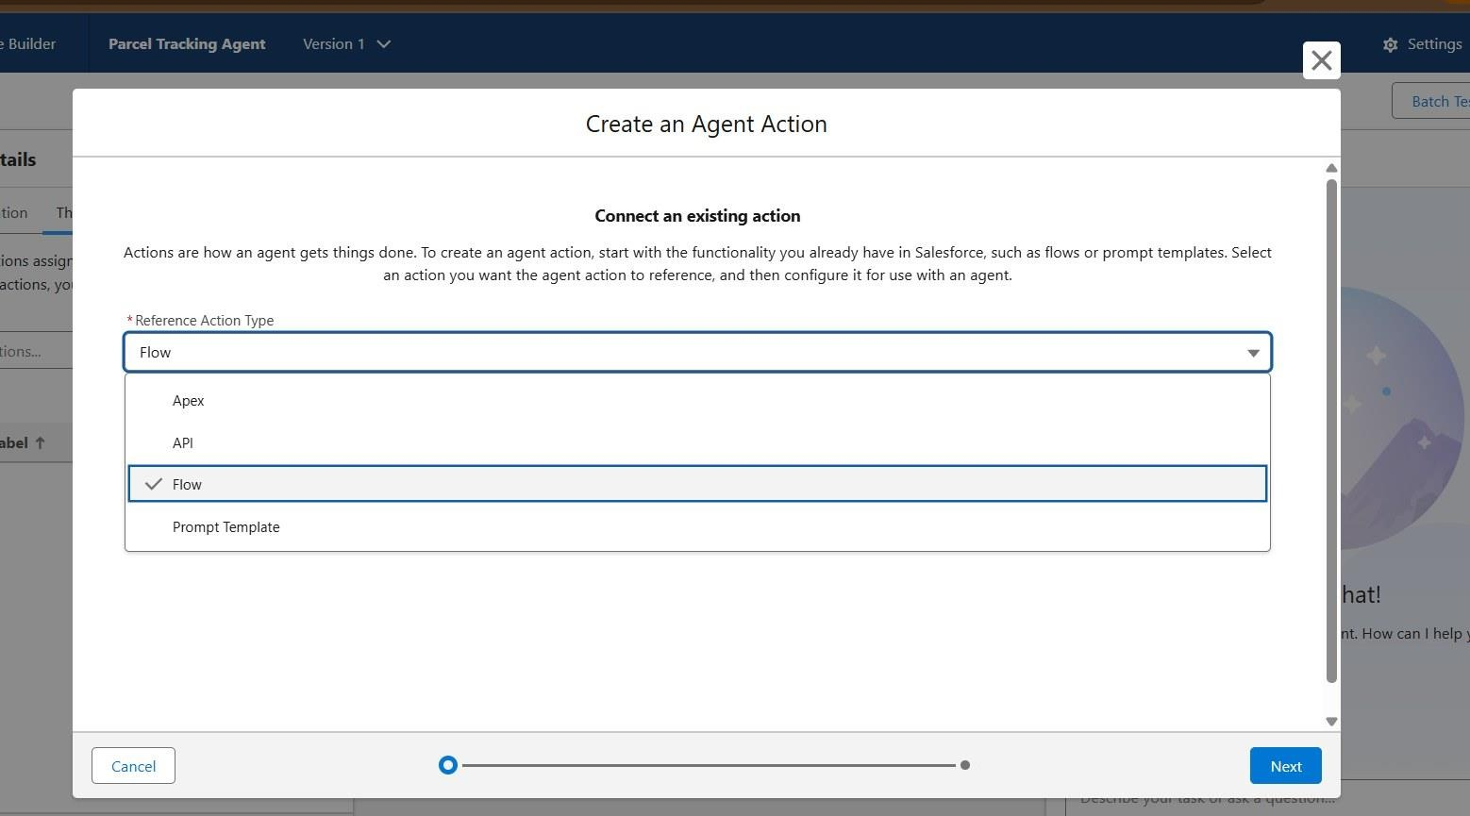
Figure 64: Create an Agent Action – Flow as reference action type
- For Reference Flow use the recently created Flow (parcel details), click Next.
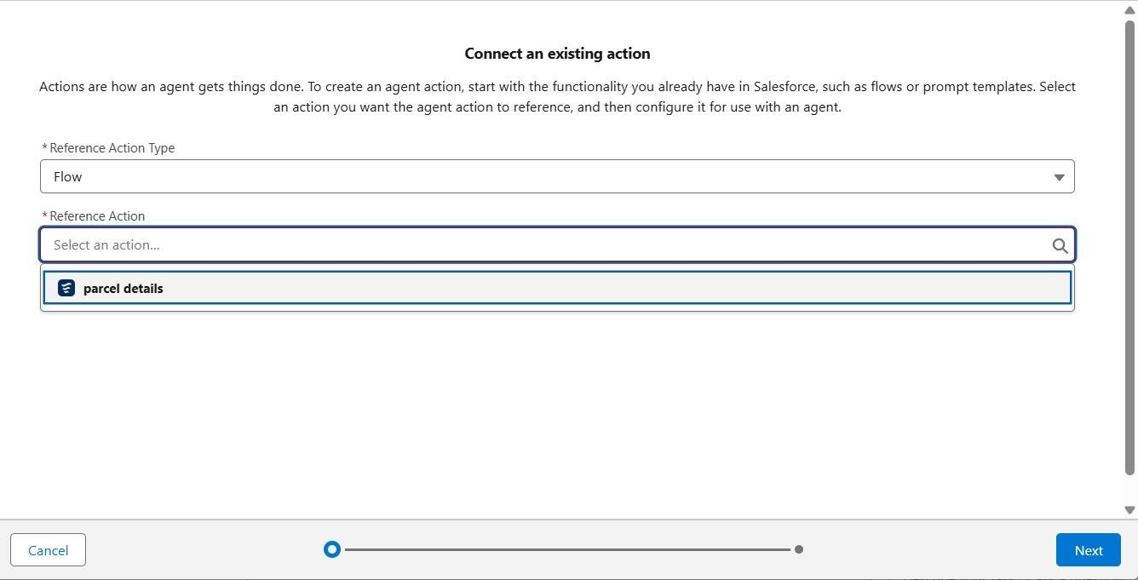
Figure 65: Selecting the parcel details Flow as the reference action
- Fill in the details for Agent Configurations.

Assign Subagent Action
While on the Agent Builder in Subagent, click on the Parcel Updates subagent.
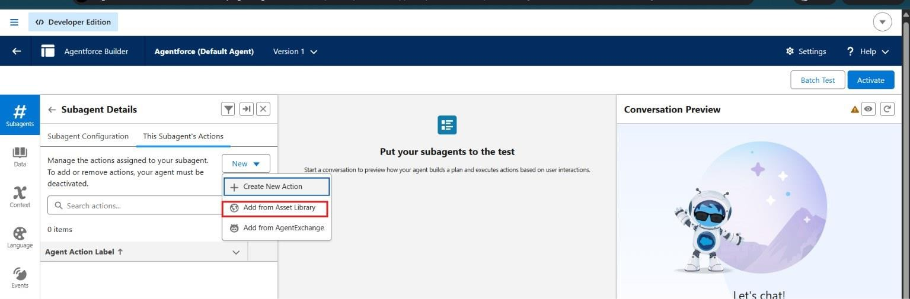
Figure 66: Subagent Details – This Subagent’s Actions
- Click on the subagent’s Actions, then select Add from Asset Library.
- Select the Flow action that was created and click Finish.
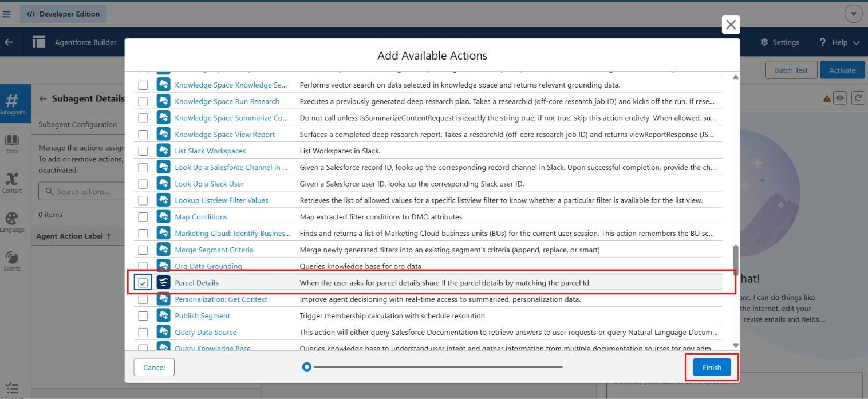
Figure 67: Add Available Actions – Parcel Details
- Click on Settings, and rename the agent to SwiftShip Tracker.

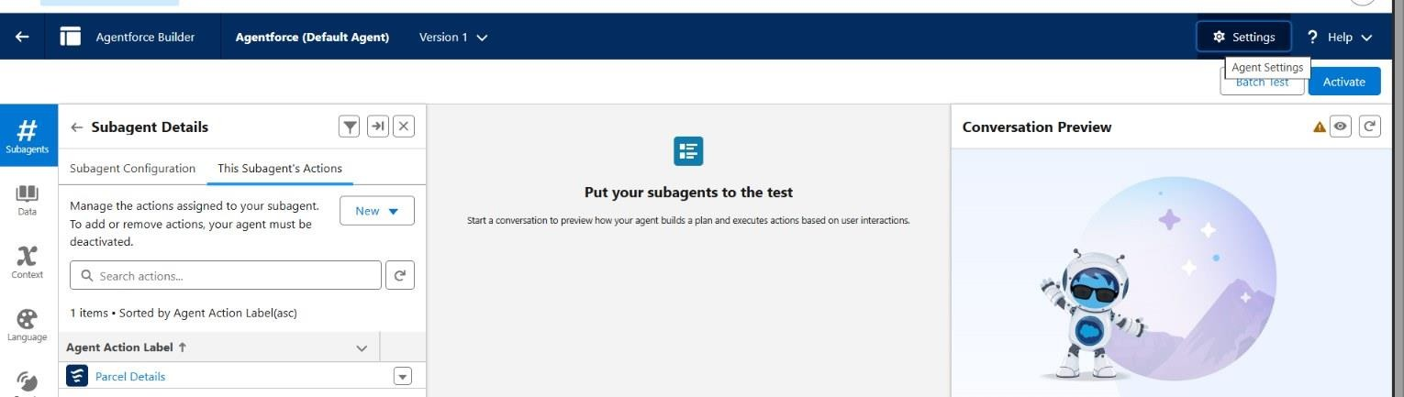
Figure 68: Parcel Details action added to the subagent
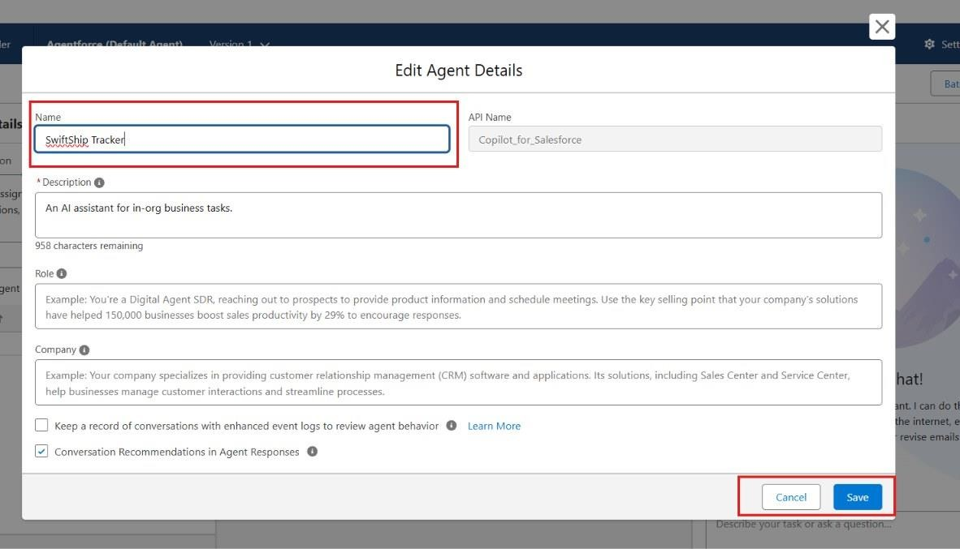
Figure 69: Edit Agent Details – agent renamed to SwiftShip Tracker
- Click Save.
- Click on Ignore & Activate, then Activate.

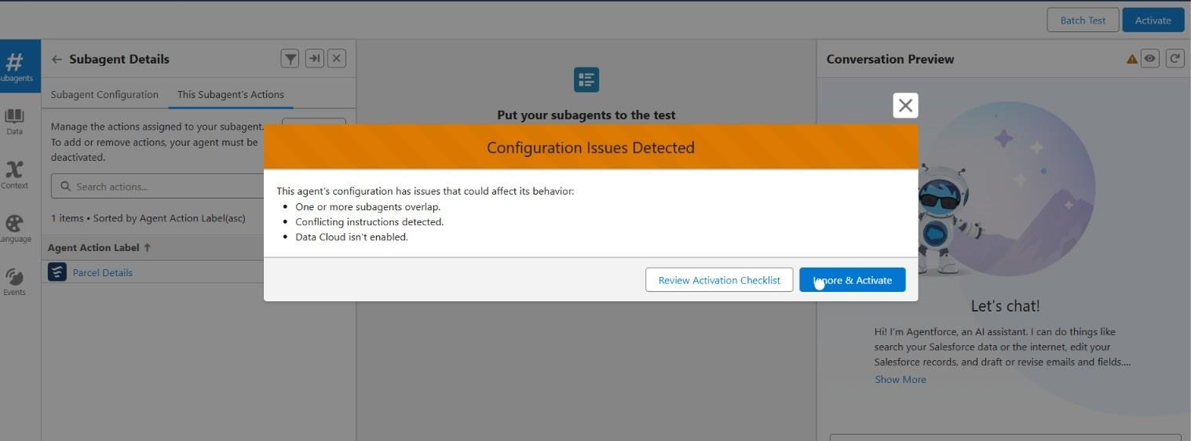
Figure 70: Activation dialog – configuration issues detected

Phase 4: Data Migration, Testing & Security
This phase validates the functionality and reliability of the agent created in Agent Builder. It ensures that the agent correctly recognizes topics, triggers the assigned Flow, retrieves parcel data, and performs the intended actions without access or permission issues. The goal is to confirm that the AI-driven agent operates seamlessly within Salesforce and provides accurate responses to parcel management queries.

Verify Agent
Go to Setup → Agentforce Agents. Open the Agents list and confirm that the SwiftShip Tracker agent appears.
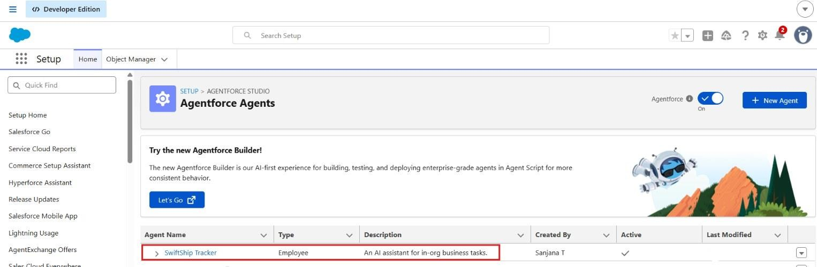
Figure 71: Agentforce Agents list showing the active SwiftShip Tracker agent

Validate Assigned Topic
In Agent Builder → Subagent, confirm that the subagent you created (Parcel Details Inquiry) is listed. Open the topic to verify:
- It contains a description related to parcel management.
- The Action / Flow (Parcel Details) is linked to this subagent.

Click Save and ensure the subagent is active.
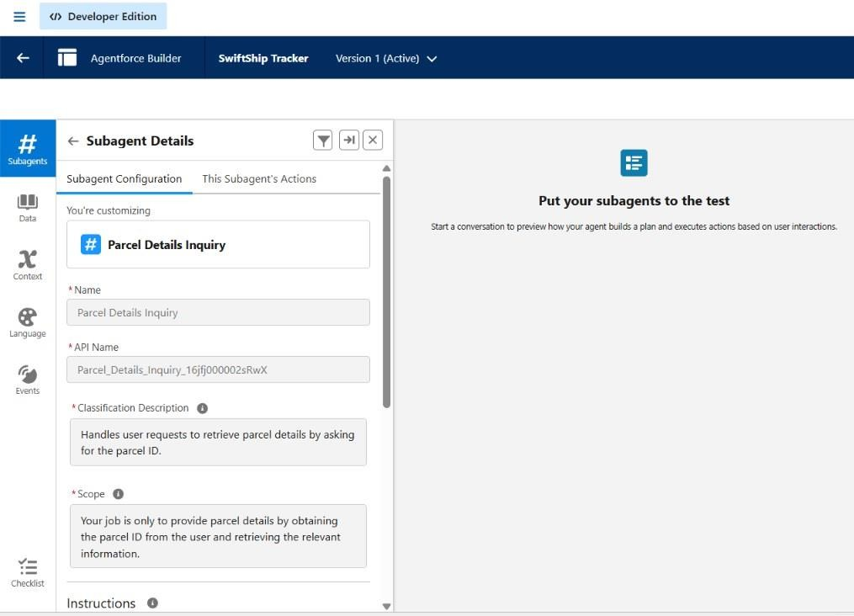
Figure 72: Subagent configuration – Parcel Details Inquiry
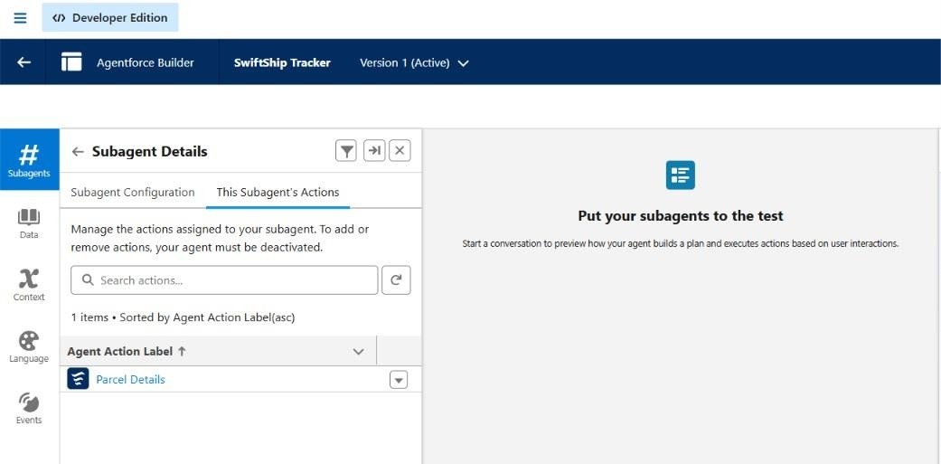
Figure 73: Subagent’s assigned action – Parcel Details

Check the Flow Association
Go to Setup → Flows and locate the Parcel Details Flow. Confirm that:
- The Flow is Activated.
- The Flow includes elements that handle the Parcel ID input, parcel details retrieval, and the prompt response output.
Open the Flow’s Advanced Settings and ensure Run in System Context (Without Sharing) if data access is restricted.
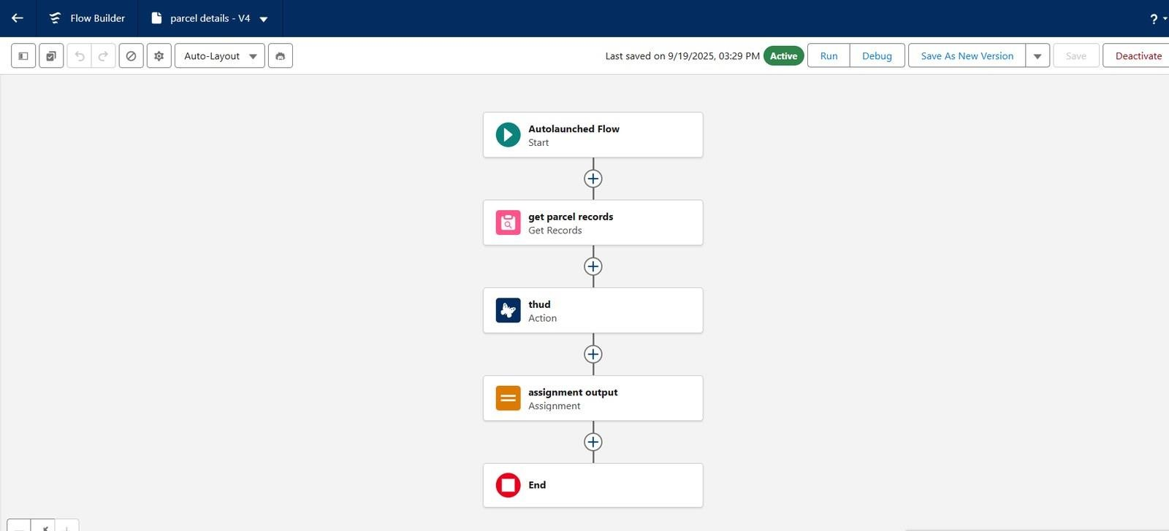
Figure 74: Parcel Details Flow – Start, Get Records, Action, Assignment, End

Activate and Test the Agent
- Return to Setup → Agentforce Agents → Agent Builder → SwiftShip Tracker.
- Click Activate (if not already activated).
- Once active, test using Conversation Preview by typing a query such as “Can I get my parcel details” and then providing the parcel ID.
- Observe the agent’s response.

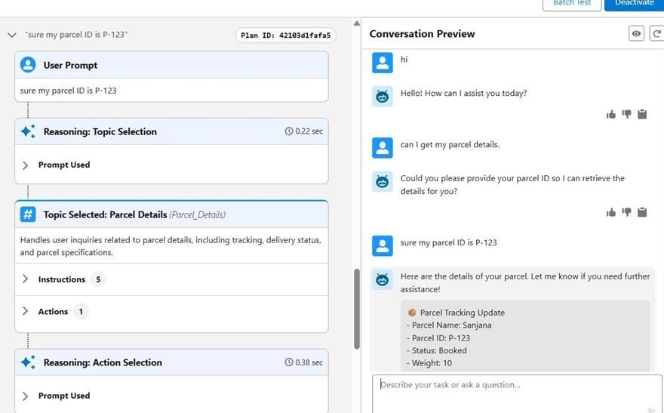
Figure 75: Agent conversation preview – parcel details returned for a Parcel ID

Validate Data in Salesforce
After the agent runs the Flow, go to App Launcher → the Parcel Tracker app and open the object tabs (Parcels, Senders, Receivers). Search for the record used during testing and verify that the record details match the information returned by the agent.
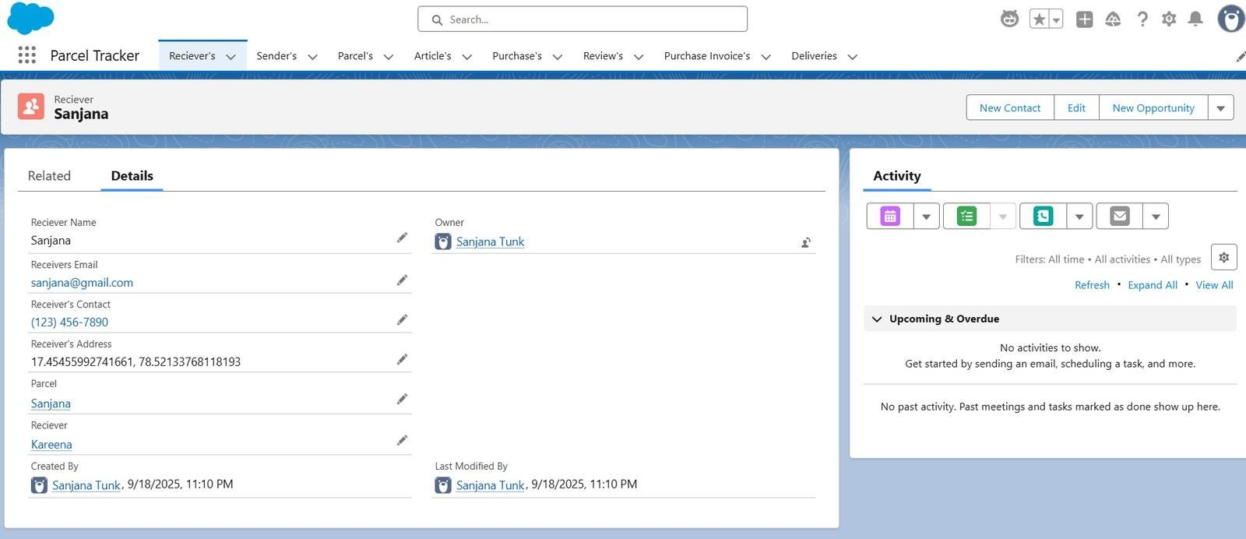
Figure 76: Receiver record in the Parcel Tracker Lightning app

Phase 5: Deployment, Documentation & Maintenance
  - In the scope of the Swift Ship Tracker (Agentforce) project implementation, the purpose of this phase is to validate that the agent, created using Salesforce Agent Builder, works as intended within the Salesforce Developer Org environment.
  - The main goal is to understand how an AI-powered service agent can be tested to ensure correct topic recognition, Flow execution, and data retrieval from Salesforce custom objects.
  - Testing is conducted within the Developer Org to simulate how the agent would perform in a live setup, ensuring that permissions, Flows, and interactions function correctly before any deployment stage.
  - Real-world production testing (UAT or sandbox deployment) is not performed in this project because:
    - Developer Edition orgs are standalone environments and do not support production-linked testing environments.
    - Enterprise-level Agentforce deployment involves sandbox testing, staging environments, and CI/CD automation, which are outside the scope of this academic/prototype implementation.
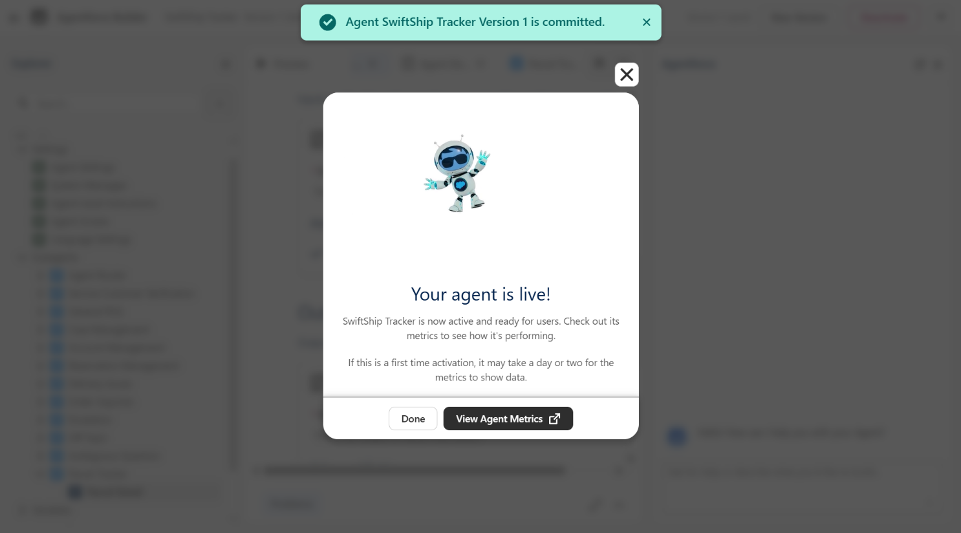

Maintenance, Monitoring & Troubleshooting
In the Swift Ship Tracker (Agentforce) project, ongoing maintenance ensures that Parcel, Sender, Receiver and Delivery data remain accurate, synchronized, and up to date. Regular monitoring helps detect issues such as misrouted agent queries, failed Flow executions, or performance delays in Agentforce responses. Troubleshooting activities include resolving configuration errors, updating Flow logic, refining agent topics, and improving prompts to enhance user interactions.
Although this project is implemented within a Salesforce Developer Org for learning purposes, in real-world enterprise deployments, these maintenance and monitoring practices are essential.
They ensure that AI-powered service agents remain reliable, scalable, and continuously aligned with evolving customer service operations and business goals.

FUNCTIONAL & PERFORMANCE TESTING
Testing was carried out in the Salesforce Developer Org using the screenshots captured during implementation. The screenshots validate object and field creation, tab creation, the Prompt Builder template, the Parcel Details Flow, the Swift Ship permission set, and the Agentforce agent that returns parcel details through a conversation. Each feature listed below was verified against the corresponding figure in Chapter 6.

Test Cases

TC ID | Test Scenario | Expected Result | Status | Evidence
TC-01 | Create custom objects | Parcel, Delivery, Sender and Receiver objects are created and deployed with reports, search and field history enabled | Pass | Figures 13, 15,  17, 33
TC-02 | Create object tabs | Custom object tabs are available for Parcel, Delivery, Sender and Receiver | Pass | Figure 21
TC-03 | Create fields and relationships | Parcel ID, Status, Weight, Estimated Delivery, Current Location, address, contact and e-mail fields and the Sender / Parcel lookups are created | Pass | Figures 24, 27,  30, 33
TC-04 | Preview Prompt Builder template | Retrieve Parcel Details resolves the prompt for a Parcel record and generates the Parcel Tracking Update | Pass | Figure 37
TC-05 | Verify Parcel Details Flow | Flow is active and runs Get Records  → Action → Assignment → End | Pass | Figures 45, 74
TC-06 | Assign permission set to agent user | Swift Ship permission set is listed in the agent user’s assignments | Pass | Figure 56
TC-07 | Verify agent, subagent and action | SwiftShip Tracker agent is active; Parcel Details Inquiry subagent is linked to the Parcel Details action | Pass | Figures 71, 72, 73
TC-08 | Track a parcel through the agent | Agent asks for the Parcel ID and returns Parcel ID, Status and Weight for that parcel | Pass | Figure 75
TC-09 | Validate data in Salesforce | Record details in the Parcel Tracker app match the information used by the agent | Pass | Figure 76

Results
In the conversation preview the agent first asked for the Parcel ID; after the user entered P-123 it returned a Parcel Tracking Update showing Parcel ID P-123, Status Booked and Weight 10 (Figure 75). The reasoning trace shows the Parcel Details topic being selected in 0.22 seconds and the action being selected in 0.38 seconds. The prompt preview (Figure 37) returned the same set of fields together with the Estimated Delivery Date. All test cases passed within the Developer Org.

Implementation Status
The table below separates the components that are demonstrated by the implementation screenshots from those that are part of the planned design and future scope.

Component | Details | Status
Custom objects | Parcel, Delivery, Sender, Receiver with tabs, fields and lookup relationships | Implemented
Lightning app | Parcel Tracker app with object tabs | Implemented
Prompt Builder | Retrieve Parcel Details (Record Summary template on Parcel) | Implemented
Flow | Parcel Details auto-launched Flow (input ids, output) | Implemented
Permission set | Swift Ship (Read, Create, Edit on the four objects) | Implemented
Agentforce | SwiftShip Tracker agent, Parcel Details Inquiry subagent, Parcel Details action | Implemented
Automation | Record-triggered and scheduled Flows, Approval Processes | Planned
Apex | Apex classes and Batch Apex | Planned
Notifications | Email Alerts and Email Templates | Planned
Customer access | Experience Cloud site | Planned
Analytics | Reports and Dashboards | Planned
Security model | Profiles, Role Hierarchy, Sharing Rules | Planned

ADVANTAGES & DISADVANTAGES

Advantages
- Centralized parcel and customer information in Salesforce.
- Provides better visibility into parcel booking and delivery tracking.
- Automates key logistics processes using Salesforce Flow.
- Agentforce enables conversational customer support and parcel-status assistance.
- Prompt Builder supports AI-powered responses and self-service.
- Reduces manual effort for customers, support teams, and administrators.
- Provides timely notifications and updates during the delivery process.
- Experience Cloud can provide customers with convenient access to tracking information.

- Supports integration with external logistics systems.
- Can scale to support multiple locations and growing parcel operations.

Disadvantages / Limitations
- Requires accurate and up-to-date parcel and customer data.
- Dependence on Salesforce configuration and automation.
- Agentforce responses depend on properly configured prompts and available data.
- External logistics integrations may increase implementation complexity.
- Flow and automation logic require regular maintenance when business processes change.
- Users need appropriate Salesforce or Experience Cloud access to use the system.
- Initial Salesforce implementation and configuration can require significant effort.
- Expanding the system to additional locations or integrations may require further customization.
- The prototype is built and tested only in a Developer Edition org; sandbox, UAT and CI/CD deployment are not performed.

CONCLUSION
The Swift Ship Tracker demonstrates how Salesforce can be used to build a centralized parcel management and tracking solution. The implemented prototype consists of the Parcel, Delivery, Sender and Receiver custom objects with tabs, fields and lookup relationships, a Prompt Builder template, an auto-launched Flow, the Swift Ship permission set, and an Agentforce agent. Apex, Email Alerts, Experience Cloud, reporting and the wider security model are part of the planned design and future scope.
The integration of Agentforce AI with Prompt Builder and Salesforce Flow provides a conversational approach to parcel tracking, enabling customers to obtain shipment information without depending entirely on manual support. The project therefore provides a practical foundation for a scalable and user-friendly parcel management solution.

FUTURE SCOPE
- Extend Agentforce capabilities for more parcel-management queries.
- Enhance real-time delivery tracking.
- Expand customer self-service through Experience Cloud.
- Add more advanced delivery-performance analytics, reports and dashboards.

- Integrate additional external logistics systems.
- Improve AI prompts and conversational experiences.
- Introduce enterprise-level sandbox and CI/CD deployment.
- Expand automation for additional parcel operations, including record-triggered Flows, Apex, Batch Apex and Email Alerts.
Continuous monitoring, prompt refinement, Flow improvement, and AI-agent scalability are the main areas for future enhancement.

APPENDIX
- A. Custom Objects: Parcel, Delivery, Sender, Receiver
- B. Standard Objects (planned): Account, Contact, Case, Task, EmailMessage, User
- C. Automation: Flows (implemented); Approval Processes, Email Alerts (planned)
- D. Apex (planned): Apex Classes, Batch Apex
- E. AI: Agentforce AI, Prompt Builder
- F. UI: Lightning App (implemented); Lightning Record Pages, Experience Cloud (planned)
- G. Security: Permission Sets, Field Permissions (implemented); Profiles, Roles, Sharing Rules (planned)
- H. Analytics (planned): Reports & Dashboards
- I. Testing: Flow, Agentforce, data retrieval, security and permission validation

REFERENCES
- Salesforce Developer Edition sign-up: https://developer.salesforce.com/signup
- Salesforce Help and Documentation: https://help.salesforce.com
- Salesforce Trailhead: https://trailhead.salesforce.com

Thank You

